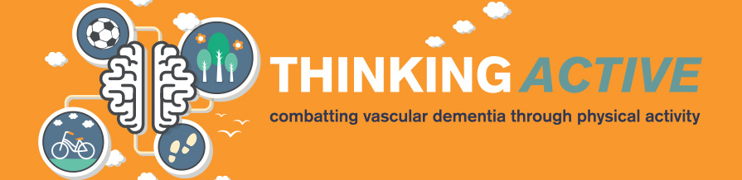

Thinking Active

Partner Application Form

Name of Organisation ……………………………………………………………
Your Details

Address ……………………………………………………………

……………………………………………………………

……………………………….Postcode………………..

Contact Name ……………………………………………………………

Contact Telephone No ……………………………………………………………

Contact Email…………………………………………………………………….

Your Organisation
Give a brief overview of your organisation (communities you work with, activities you deliver, number of volunteers you engage etc) (500 words max)

Where do you intend to hold your Thinking Active sessions?
Your project

When will your activity place? (time of day/day of week)

Who will lead the Thinking Active sessions, what are their qualifications?

What do you consider your catchment area to be/which community will you target? (200 words max)

How do you intend to promote the sessions, what will be the mechanism for booking onto these sessions? Where will you recruit your participants from? (400 words max)

How do you plan on making the sessions sustainable beyond the 12 weeks? (300 words max)

Do you have an organisational constitution? Yes/ No

Do you have an Equity Policy? Yes / No

Do you have a Welfare Policy? Yes / No

Do you have appropriate Public Liability insurance? Yes/ No Please provide details

Please complete the attached application form and return to communications@staffordshire.gov.uk by 26th February

If you have any further questions about Thinking Active please contact Ben Hollands on bhollands@staffordbc.gov.uk or 07812 351083 (please note, due to annual leave Ben will be unavailable between 5th -19th Feb).

