Tell us About Your Project / Activity ………………………
Name of Project / Activity

Dates & Times of Activities
(Please feel free to provide a web link to where these are listed if you prefer)
Messaging: What is your key message and what core values are you trying to appeal to?
- looking good
- 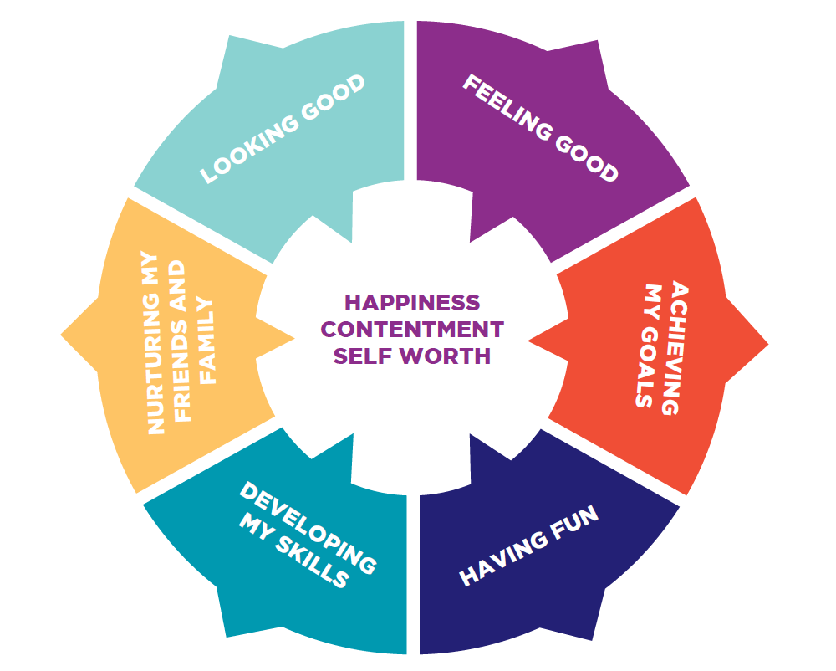feeling good
- achieving goals
- developing skills
- nurturing friends and family
- having fun

(These values represent what is important to
women in modern life and how they want to
spend their time and energy. Different women at
different times in their lives will place different
levels of importance on each of these values).

Ages: Please tell us the age groups that you are targeting, ideally this will be a specific age band rather than all ages?

Quotes: We are looking to bring activities to life as much as possible; please can you provide us with quotes from those that have already taken part in your activities?

Pictures / Video: Please could you provide us with a picture of your activity or selfies of the girls / women involved in your activity? These can just be taken on a phone and don’t need to be taken on a professional camera. If any of your participants have the TGC t-shirts, photos including these would be great.

Social Media Links: Please provide us with the link to your social media channels to allow us to share your information etc….

Facebook –
Twitter / Hashtags –
Instagram –
You Tube –
Website -

Return to: Naomi Bird – nbird@staffordbc.gov.uk by Thursday 20th January 2017.
Thank You !

