STAFFORDSHIRE SCHOOLS' TABLE TENNIS ASSOCIATION
INDIVIDUAL CHAMPIONSHIPS

ENTRY FORM
Please enter the following players, listed in ranked order.

BOYS | GIRLS
UNDER 19 (6th Form)  1.  2.  3.  4. | UNDER 19 (6th Form)  1.  2.  3.  4.
UNDER 16 (Yr 9, 10, 11)  1.  2.  3. | UNDER 16 (Yr 9, 10, 11)  1.  2.  3.  4.
UNDER 13 (Yr 7, 8)  1.  2.  3. | UNDER 13 (Yr 7, 8)  1.  2.  3.
UNDER 11 (Primary)  1.  2.  3. | UNDER 11 (Primary)  1.  2.  3.
STAFFORDSHIRE SCHOOLS
TABLE TENNIS ASSOCIATION
INDIVIDUAL CHAMPIONSHIPS
U19+U16 Boys and Girls-Mon 3rd Feb 2020
U13+U11 Boys and Girls- Mon 10th Feb 2020
(Both events 4pm start 4-6pm approx)
Venue: Clayton Hall Academy, Clayton lane
Newcastle Under Lyme Staffordshire ST53DN
Follow SSTTA on facebook
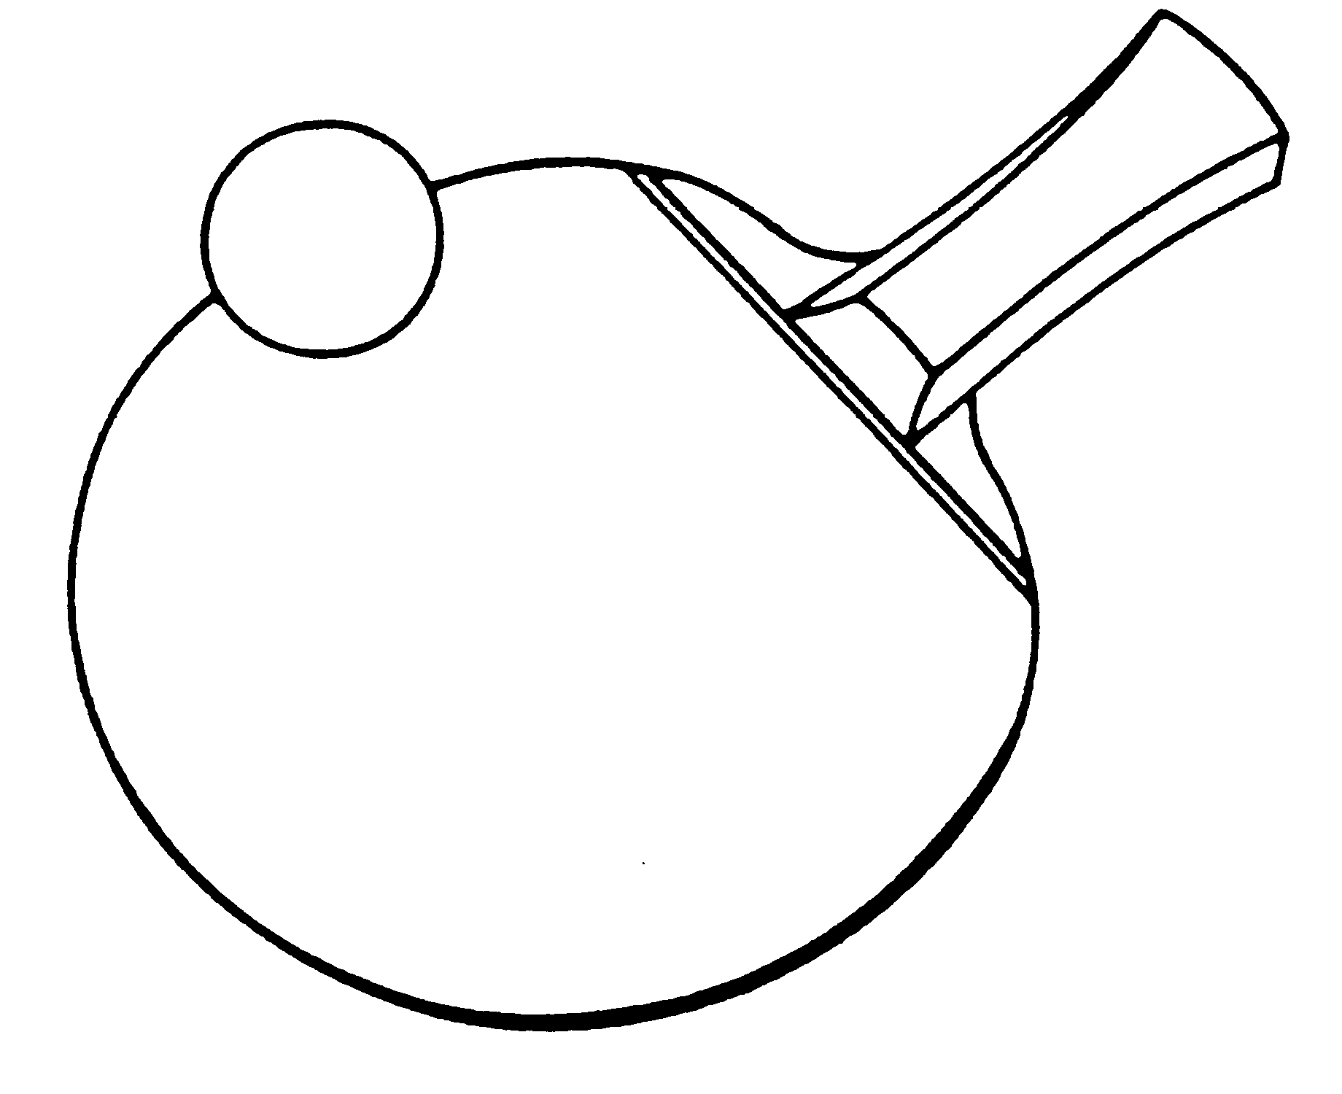
https://tabletennisengland.co.uk/clubs/schools/

Closing date for entries: Friday January 24th 2020
This event is a qualifying competition for the
Butterfly Schools' National Individual Championship Finals

RULES
- All players must attend an affiliated school or college and be in full time education.
- Eight events - Boys and Girls under 19, 16, 13, and 11. Ages as at 1st September (Current School Year).
- Players may enter ONE EVENT only.
- Schools should not enter more than THREE players in any one event. (4 FOR U19 and U16 Girls only).
- Entries to the Organiser R.Rhodes by Friday 24th January 2020
- Players or teachers in charge should report to control by 4pm.
- Late arrivals are liable to be scratched or conceded their first scheduled match.
- Suitable sportswear MUST be worn. NO WHITE CLOTHING. Tracksuit trousers not to be worn during play.
- All correspondence or requests for information re the competition should be addressed to the Organiser.
- Matches will be played best of 3 or 5 games dependant upon number of entrants, 11 up changing service after every 2 points.
- Please note all winners will have to pay/or their school for entry to the National Individual final (forms to be distributed on the night of play for winners
- Runners up’s details will be required in case of the Winner not entering

Follow Staffordshire Schools Table Tennis Association on facebook
No entries will be accepted unless accompanied by the appropriate fees.

It is hoped to play in groups. The number in each group will depend on the size of entry.

The winner of each age group will represent their county in the ESTTA Butterfly National Schools' Individual Championships.

STAFFORDSHIRE SCHOOLS’ TABLE TENNIS ASSOCIATION
Individual Championships

ENTRY FORM
Name of School:
Address of School:
Post Code:
Teacher in charge:
E-mail:
Mobile No: (for emergencies)
Signed:_________________ ______________Headteacher/Deputy Headteacher

N.B. This form must be signed by the Headteacher/Deputy Headteacher

I enclose the entry fee for_____players at £2 each. Total £ _______

Cheques and Postal Orders should be made payable to Staffordshire Schools Table Tennis Association
BACS Payment to Account Number 65777530 Sort Code 556101.

Please list players overleaf
(if more space is required please attach separate sheet)

Please return to:
Robert Rhodes 6 Fellbrook Lane Bucknall Stoke On Trent ST28AQ
by Friday, 24th January 2020(all events)
Telephone: 07745869342
Email:rhoderz@hotmail.com

LATE ENTRIES WILL NOT BE ACCEPTED

