STAFFORDSHIRE SCHOOLS’

TABLE TENNIS ASSOCIATION
TEAM
CHAMPIONSHIPS 2019
U16 Boys and Girls Monday 21st Oct
U13 Boys and Girls Monday 11th Nov
U11/U19’s Monday 18th Nov
Time-4-6pm (all dates)
At: Clayton Hall Academy, Clayton Lane, Newcastle Under Lyme, Staffs ST53DN
Follow SSTTA on facebook
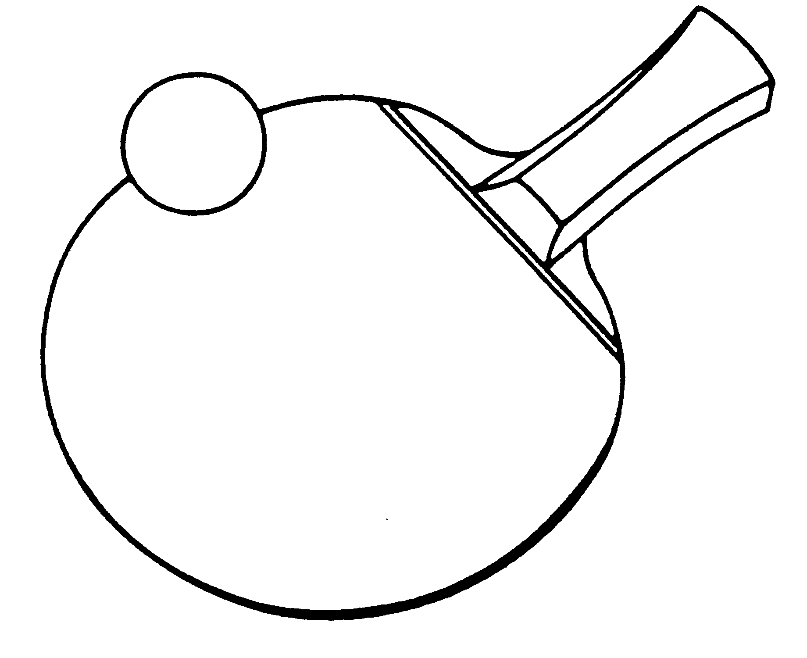
https://tabletennisengland.co.uk/clubs/schools/

Closing date for entries: Friday 18th October 2018

This event is a qualifying competition for the
Butterfly School Team Championship Zone Finals
RULES

1. All participating Schools and Colleges must be affiliated to their respective County Schools T.T.A. (entering the events and paying the appropriate fee will affiliate your school)
2. Four players per team to play in ranked order except in the Girls' Under 19 team which will consist of only two players . All players must be in FULL TIME education.
3. Eight events - Boys under 19, 16, 13 and 11, and Girls under 19, 16, 13, and 11. Ages as at 1st September (Current School Year).
4. At least one playing member of each team MUST be competing in the youngest event for which he/she is eligible. e.g. An Under 19 team MUST have at least one playing member of the team who is ineligible for U16/U13/U11 events.
5. Players may only play in one event.
6. Suitable sports wear MUST (be worn. NO WHITE CLOTHING. Tracksuit trousers not to be worn during play.
7. Entries to the Organiser by Day, Date.
8. Players, or teachers in charge should report to control by time.
9. Late arrivals are liable to be scratched. Contact in advance if issues
10 No entries will be accepted unless accompanied by the appropriate entry fee. No entry on the day
11. Matches will be played best of 3 or 5 games (dependent upon time), 11 points up, changing service after every 2 points.
12. The winning teams in each age group will represent their county in the ESTTA Butterfly School Team Championship Zone Finals.
13. Please use this entry form and copy as an invoice for your school Burser and forward a copy to Rob Rhodes (post or email) before the deadline entry which is Friday 18th October 2019.
14. All fees must be paid before the competition dates you enter, otherwise you will forfeit your teams on the day (please make it your responsibility to ensure your BURSARS have made the payments before the dates of your teams events. Payment via BACS or Cheque. Thank you.
Follow Staffs Schools Table Tennis Association on Facebook
The full Team Championship Regulations can be found on the TTE Website

https://tabletennisengland.co.uk/clubs/schools/
STAFFORDSHIRE SCHOOLS’ TABLE TENNIS ASSOCIATION
Team Championships

ENTRY FORM
Name of School:
Address of School:
Post Code:
Teacher in charge:
E-mail:
Mobile No: (for emergencies)
Signed: ____________________________Headteacher/Deputy Headteacher

EVENTS: (Tick events to be entered)
I would like to enter a team in the Boys under 19 event
I would like to enter a team in the Girls under 19 event (2 players only)
I would like to enter a team in the Boys under 16 event
I would like to enter a team in the Girls under 16 event
I would like to enter a team in the Boys under 13 event
I would like to enter a team in the Girls under 13 event
I would like to enter a team in the Boys under 11 event
I would like to enter a team in the Girls under 11 event
I enclose the entry fee for____ teams at £6 per team. Total £ ________
Cheques should be made payable to:
Staffordshire Schools Table Tennis Association.
BACS PAYMENT TO
ACCOUNT: 65777530 SORT CODE: 556101

Please return to:
Robert Rhodes, 6 Fellbrook Lane Bucknall Stoke on Trent, ST28AQ
by
Friday, 18th October 2019

Telephone: 07745869342 Email:rhoderz@hotmail.com

