Governance Statement
2018-19
Sport Across Staffordshire and Stoke-on-Trent
Governance Statement 2018-19

- Introduction

Following a wholescale review of SASSOT’s governance policies in 2017-18, this year has been one of learning and consolidation.

We completed the restructure of our Board, recruiting five new board members (four of whom are independent) who bring an exciting set of skills to the existing expertise of the group.

Additionally, in September, we were confirmed by Sport England as achieving compliance with Tier Three of A Code for Sports Governance, a requirement for organisations receiving Sport England funding.

The Board has also begun the process of reviewing the financial benefits of becoming an independent organisation versus remaining as a hosted body. This work will continue in to 2019-20, enabling the Board to make an informed decision for SASOT’s long-term future.

- Governance and Structure

  - A Code for Sports Governance
All organisations which receive funding from UK Sport or Sport England are now required to comply with the appropriate Tier of A Code for Sports Governance. For County Sports Partnerships such as SASSOT, this meant compliance with Tier Three by 31.03.18.

We submitted all evidence to Sport England by that deadline, and in September 2018 we were informed that we had been assessed as compliant.

2.3 Constitution
The constitution is reviewed annually. In January 2019, the Governance and Appointments Group carried out this review. Various items were re-ordered and re-worded for clarity, and the following minor amendments were put forward:
- The Diversity statement previously adopted by the Board has been added.
- Statements confirming that deputies can attend in an observer capacity but that they cannot vote, and that proxy votes are not allowed, have been added
These amendments were adopted by the Board on 23.01.19

A copy of the new constitution can be found here.

2.4 Board Membership
Board members who have served during 2018-19 are listed below:

Name | Status | Start of Term | End of Term | Attendance | Sub-Group Membership
Malcolm Armstrong | Independent (Chair) | 17.10.17 |  | 4/4 | FAG  GAG  SAG
Tim Clegg | Representative | 11.07.18 |  | 2/3 | SAG
Janene Cox OBE | Representative | Pre July 10 | 18.04.18 | N/A
Angela Dale | Representative | 02.11.11 |  | 3/4
Cllr Mark Deaville | Representative | 17.10.17 |  | 2/4
Alistair Fisher | Representative | 17.05.17 |  | 4/4 | SAG
Toyin Higgs | Independent | 24.10.18 |  | 2/2 | GAG
Wendy Jennings | Representative | 17.10.17 | 11.07.18 | 1/1
Ian Kelsall | Independent | 18.04.18 |  | 4/4 | GAG
Tony McGovern | Representative | 28.01.15 | 18.04.18 | N/A
Prof. Derek Peters | Independent | 18.04.18 |  | 3/4 | SAG
Dave Pinnock | Independent (Senior Ind. Dir.) | Pre July 10 | 18.04.18 | N/A
Kimiyo Rickett | Independent (Senior Ind. Dir.) | 24.01.18 |  | 4/4 | FAG  GAG  SAG
Rebecca Roberts | Independent | 24.01.18 |  | 4/4
Jonathan Topham | Representative | 17.05.17 |  | 2/4 | SAG
Prof. Pauline Walsh | Independent | 18.04.18 |  | 3/4

Key: FAG – Finance and Audit Group
GAG – Governance and Appointments Group
SAG – Strategy Advisory Group

Board membership at 31.03.19 stood at 12 members, with 7 independent and 5 female.

Profiles of current Board members can be found here, and a diagram of the Board’s structure is shown below:

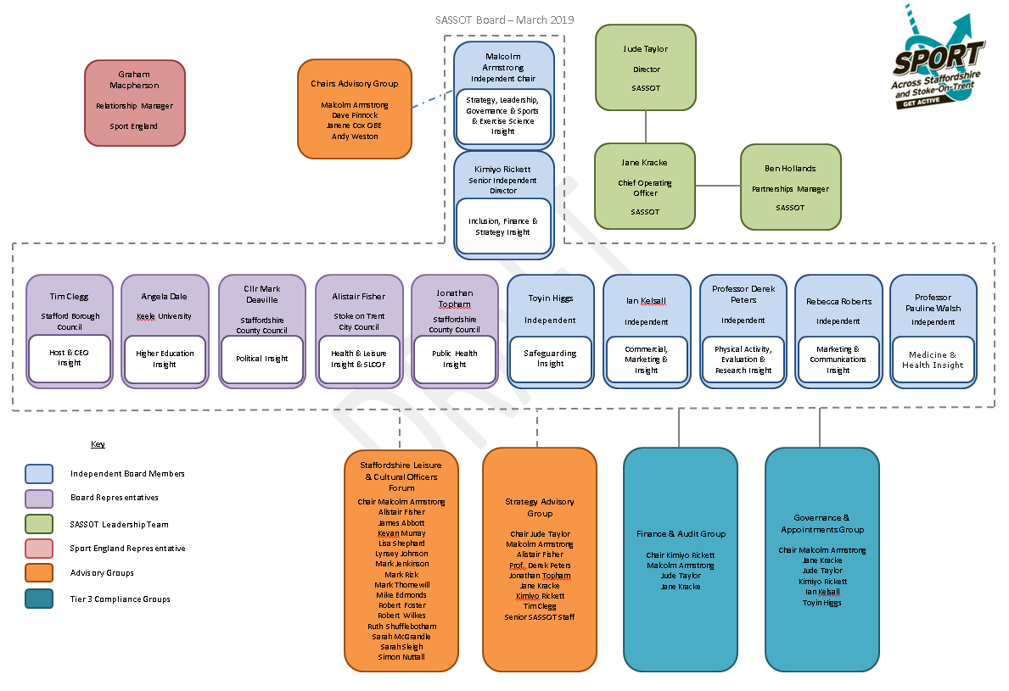

2.5 Diversity in Governance and Leadership

Our Diversity in Governance and Leadership Action Plan was officially signed off by Inclusive Boards on behalf of Sport England in February 2019. A copy can be viewed here.

Progress regarding the number of female and independent Board members is outlined below:

 | As of 31.03.17 | As of 31.03.18 | As of 31.03.19
Number of members | 11 | 11 | 12
Female | 3 (27%) | 5 (45%) | 5 (42%)
Independent | 3 (27%) | 4 (36%) | 7 (58%)

2.6 Sub Groups

The Board currently has four sub-groups, as illustrated above.

2.6.1 Staffordshire Leisure and Cultural Officers Forum (SLCOF)
- SLCOF commissioned an independent review during Summer 2018 in order to agree a new purpose and priorities.
- The Chair of SLCOF attended a GAG meeting and proposed that SLCOF would become a formal sub-group of the Board, with the Board Chair also chairing this group. This was agreed by SLCOF and the Board
- The SLCOF meeting in March 2019 was also attended by the Chairs of the SDO Forum and Facility Managers Forum (which sat below SLCOF), and it was agreed that:
  - Membership of SLCOF should be targeted at LA strategic decision makers
  - The SDO and Facility Managers Forums should be merged
  - That the Purpose agreed through the consultant’s review is still appropriate

2.6.2 Strategy Advisory Group
Key work areas during 2018-19 include:
- Overseeing the preparation for the Performance Management and Improvement Framework (see below)
- Overseeing the development and implementation of the Improvement Plan
- Reviewing the Stakeholder Engagement Event (February 2019)

2.6.3 Finance and Audit Group
Key work areas during 2018-19 include:
- Ongoing updating and monitoring of the 4-Year Financial Forecast
- Ongoing monitoring of income / expenditure against the annual budgets
- Full revision of the organisation’s Risk Register and Risk Management Policy
- Completion of an Effectiveness Checklist

2.6.4 Governance and Appointments Group
Key work areas during 2018-19 include:
- Consideration of whether SASSOT should become Independent
- Staff Satisfaction Survey and interim temperature check
- Review of the relationship between SLCOF and the Board (see above)
- Implementing interim arrangements while the Director took maternity leave
- Revision of constitution

Terms of reference and minutes from each sub-group can be found here.

2.7 Remuneration of Board Members
As outlined in SASSOT’s constitution, the role of Board members is voluntary and no Board members shall receive any remuneration other than reasonable out of pocket expenses.

- Performance Management and Evaluation Framework (PMIF)

3.1 Overview
PMIF is Sport England’s new way of measuring the effectiveness of individual Active Partnerships. Using Quest, an established improvement tool for the sport and leisure industry, APs were required during 2018-19 to self-assess against five tailored modules and to then undergo a rigorous two-day independent assessment.
SASSOT’s two-day assessment took place on 17th to 18th December 2018, and was the culmination of a lot of self-assessment and evidence gathering both from within the team and Board, and with a wide range of our partners. The organisation received a ‘Good’ rating across all areas, with the following key strengths / areas for improvement indentified.
3.2 Strengths
“SASSOT has a clear idea of where the organisation wants and needs to go, maintaining a focus on addressing inactivity and delivering the strategic priorities through a place-based approach, and it is developing the culture, the people and the collaborations needed to get there”
“There are examples of where physical activity has been heightened in other agendas, for example with Staffordshire Health and Wellbeing Board, Staffordshire Public Health and the Police and Crime Commissioner”
“The SASSOT team has been restructured to align with the Strategy and the staff have a considerable amount of knowledge, experience and competencies to deliver the priorities, and have the drive, passion and determination to make a difference through the new place-based approach”
“SASSOT has a very inclusive collaborative approach. Leadership is evident and the team feel empowered to engage with relevant networks, develop new partnerships and make decisions.”
3.3 Areas for Improvement:
“SASSOT has widened and deepened its reach and engagement with partners (existing and new). However, developing a more in-depth understanding of partners’ objectives and motivations may help ensure high-level ownership and understanding of the Strategy and identify new innovative ways to deliver against shared outcomes”
“Partners have indicated that they would like SASSOT ‘to raise awareness of physical activity in the area’ and on occasions to be firmer and bolder in advocating its value at a strategic level to influence other agendas.”
“The Board and team could consider raising the team's profile by celebrating success, achievements and learning. They could be more outward facing and shout louder about what they do and the value of sport and physical activity”
3.4 Improvement Plan
Using the feedback from the self-assessment and formal assessment, an Improvement Plan was drawn up and signed off by Sport England at a ‘Round Table’ meeting in March 2019.

The three strategic priorities for 2019-20 as identified in the Improvement Plan are:
- Become more effective at measuring and demonstrating impact
- Improve understanding and ownership of our strategy and the PlaceBased Approach
- Enhance SASSOT’s reputation locally and nationally through sharing our learning and successes
To this end, a successful Stakeholder Engagement Event was held in February 2019. The Team provided an overview of the work done this year and, through case studies and presentations, we gave everyone insight into some of the key work areas and the impact they are having.
The draft Services Offer document (see 5 below) was outlined and attendees had the opportunity to discuss this and where they felt SASSOT’s priorities should be focused during 2019-20
- Strategy

  - Introduction
SASSOT’s new strategy for 2018-21 was developed during 2017-18 and was launched in April 2018 at an event attended by a wide range of our current, new and potential partners.

This strategy represents a new direction of travel for SASSOT as we attempt to respond to the ever-changing physical activity and sport landscape. At its heart is an unwavering focus on the needs of our most inactive communities. Working at this locality level will allows us to understand the motivations, barriers and behaviours of residents in those places. Working with partners we aim to address these local issues and turn the dial on inactivity, ensuring every resident can enjoy the economic, social and health benefits of an active lifestyle

  - Strategy Overview

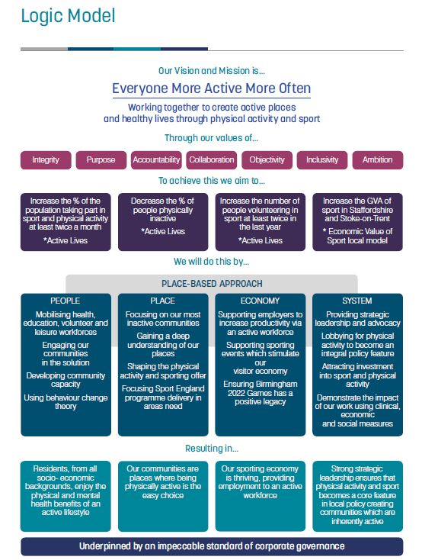

A copy of our full Strategy can be found here

- 2018-19 Delivery
A copy of SASSOT’s annual report for 2018-19 can be found here

A more detailed account of the team’s work can be found in the Annual Delivery Plan. A new template for the Delivery Plan was developed for use during 2018-19, making it much easier to link actions and progress updates to our strategic priorities. We also developed a Delivery Plan Dashboard, providing Board members with a quick visual aid to progress against our strategy. Quarterly Annual Delivery Plan updates and Dashboards are include in each Board Meeting’s papers and can be found here.

A key priority for SASSOT during 2018-19 was to clearly articulate the services we offer, and these are summarised in our Services Document.

- Finance

  - Annual Accounts
SASSOT’s Reserves Statement for 2018-19 can be found below:

Annual | Budget (£) | Actual (£)
Carry Forward from 17-18 | (394,980) | (394,985)
Income | (624,040) | (646,716)
Expenditure | 661,360 | 572,103
Net Carry Forward to 19-20 | (357,660) | (469,598)
Of which Restricted | (66,880) | (119,319)
Of which Allocated | (169,520) | (158,390)
Of which Unrestricted | (121,260) | (191,889)

- The Restricted Carry Forward includes the receipt of grants during 2018-19 where partial delivery will take place during 2019-20.
- The Allocated Carry Forward is the amount needed to cover our liabilities as of 31.03.19
A copy of SASSOT’s full, audited accounts is available on our website here.
6.2 Four-Year Financial Forecast
Throughout 2018-19, the Four-Year Financial Forecast was updated and adjusted to take into account confirmed funding, staff changes etc. This was monitored by the Finance and Audit Group, and various versions can be viewed with the Board Meeting papers here.

As per 2017-18, SASSOT should end the current Sport England funding cycle (to 31.03.21) with all its liabilities covered and with additional unrestricted reserves. However, assuming funding levels from Sport England and local partners remain the same to 31.03.22, and levels of staffing and delivery also remain comparable, SASSOT will end 2021-22 with a significant deficit.

For this reason the Board tasked the Governance and Appointments Group with investigating the financial and other benefits of becoming an independent charity (see below).

- Independence

  - Overview
SASSOT’s hosting arrangement with Stafford Borough Council has been a positive and value-for-money arrangement for SASSOT over many years. We have benefitted significantly from being able to utilise the services and expertise of Stafford BC’s various departments as part of our all-inclusive hosting arrangement.
However, with all members of the SASSOT team being employed by Stafford Borough Council under Local Government terms and conditions, our on-costs are increasing substantially year-on-year and as outlined above we are forecast to move into a deficit of £67,670 by the end of 2021-22.
The two main reasons for this are:
  - Pension contributions: all staff are members of the Local Government Pension Scheme (LGPS), administered by Staffordshire County Council. As well as contributing 16.8% of staff salaries to the Pension Scheme every month, SASSOT is required to make an annual payment towards the pension deficit. This increases by 2% year on year and currently stands at 14% of annual salaries
  - Redundancy: Stafford Borough Council offers staff in the LGPS an enhanced redundancy entitlement after three years of continuous service which can be more than triple the statutory redundancy entitlement, and SASSOT is expected to maintain sufficient reserves to cover our entire redundancy liabilities (currently £158,390, increasing to £229,650 by 2021-22).

  - Progress So Far
Given the above figures, the Board agreed to investigate whether there is a potential cost saving by establishing SASSOT as an independent organisation and, if so, the likely scope of this saving and the implications of realising this saving on both the team and the organisation as a whole.
Following an Away-Day in November 2018 when the Board heard from two other Active Partnership Directors who had made the move from Hosted to Independent, the Board committed to making a decision at their meeting in July 2019 about whether moving forward with independence is the best option for the organisation. In order to be able to make an informed decision, Board members agreed they needed to have a full understanding of the potential advantages / disadvantages of this and of whether becoming independent will give SASSOT the necessary financial savings to support its long-term financial sustainability.

To support this process, SASSOT secured funding from Sport England to engage a consortium of consultants. During the first three months of 2019-20 they will be consulting with staff, outlining TUPE considerations, confirming whether Best Value Directions applies and identifying the potential cost savings and additional costs associated with independence.

- Risk Register and Risk Management Plan

The Finance and Audit Group (FAG) carried out a full review of SASSOT’s risk register and Risk Management Plan, and a new version was produced. This is reviewed on a quarterly basis at FAG meetings, with any amendments being taken to the Board for approval. Copies of the Register / Plan can be found within the Board Meeting papers here.

As part of this review, the following three key risks were identified and actions agreed to mitigate them:
- Lack of Financial Sustainability
- Non-Delivery of Agreed Outcomes
- Ineffective Performance Management

