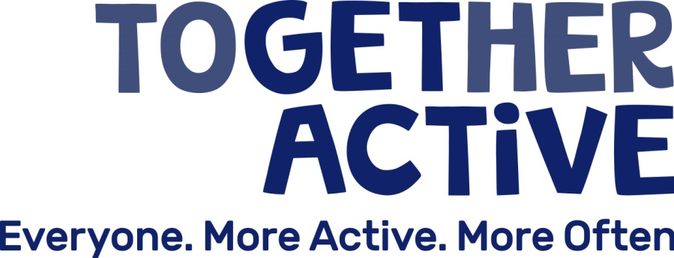

JOB DESCRIPTION

JOB TITLE | Digital, Campaigns & Health Manager
LOCATION | Stafford
HOURS | Full Time (37 hours per week)
SALARY  REPORTING TO | £35,000  Chief Executive Officer
RESPONSIBLE FOR: Digital and Events Officer

We are looking appoint amazing people with values strongly aligned to our own. These values underpin everything we do, and mean being a part of our team will always be a fulfilling experience. Below are the values and behaviours we care about most. If this sounds like you and the people you’d like to work alongside, we’d love to hear from you.

- We are focused: everything we do will help people to be more active.
- We are relentless and passionate about the importance of sport and physical activity
- We leave nobody behind: we do not accept that age, sex, disability, ethnicity or income should determine how active you are.
- We constantly work to break barriers of inactivity down, whether that’s through our partnerships or directly with the communities we support.
- We never go it alone, we work to develop collaborations that are capable of sparking change

Job Purpose

The Digital, Campaigns & Health Manager will drive Together Active’s approach to digital innovation, chiefly through the strategic management of our Open Data-driven platform Active My Way. They will be responsible for our Information, Advice and Guidance service with a particular focus on stakeholder communications and campaigns. They will influence and support health partners in ensuring physical activity features strongly in policy and investment.

Main Duties and Responsibilities

- To oversee the strategic and commercial management of Active My Way (our open data activity finder platform)
- To support local physical activity provider networks to build an open and trustworthy data ecosystem across Staffordshire and Stoke-on-Trent
- To collaborate with partners to stimulate digital innovation in the field of sport and physical activity
- To manager our our Information, Advice and Guidance portfolio including developing effective marketing communication plans and initiatives, web & social media platforms
- To support partners to land national and local campaigns and help them develop and shape their messaging to reflect the needs of the local population
- To continue the development of our relationships with health bodies (Including Health & Well-being Boards, Public Health & Clinical Commissioning Groups) ensuring physical activity is embedded in policy, commissioning and investment

General

- To monitor and evaluate the implementation and impact of each work area, obtaining KPIs and qualitative / quantitative evidence and reporting to Sport England, the Together Active Board and partners as requested.

- To manage the budgets for each work area, allocating resources as appropriate and monitoring expenditure on an on-going basis.

- To champion equality and diversity in sport and physical activity and to ensure it is embedded in this work.

- To be responsible for health, safety and welfare of the staff under your control.

This job description is not necessarily an exhaustive list of duties but is intended to reflect the range of duties the post-holder will perform. The job description will be reviewed regularly and may be changed in the light of experience and in consultation with the post-holder.

PERSON SPECIFICATION

 | Essential | Desirable
Qualifications | Maths & English GCSEs (or equivalent) A-C | Degree or equivalent in a relevant field
Experience | Significant experience of Stakeholder management  Management of digital platforms  Working within, or in partnership with, health bodies  Developing effective marketing and communication plans and initiatives  Establishing and managing monitoring and evaluation systems.  Managing and developing staff | Commercialisation of products/ services  Working with Open Data  Financial management  Project management.
Knowledge | Health landscape  Health policy  Wider agenda issues relating to sport & physical activity such as health and social wellbeing | Basic principles of behaviour change  Key issues relating to Open Data  Local government landscape including leisure outsourcing
Skills | Ability to develop high quality, compelling insight using a range of sources and use this to effectively influence decision making  Ability to motivate, enthuse, persuade, negotiate and influence  Strategic, critical thinking and decision making skills  Management of conflicting priorities and pressures

