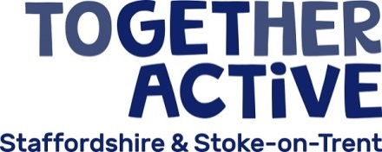

Trustee

PERSON SPECIFICATION

Core competencies:
- Leadership – Effective leadership skills. Has a successful track record of leadership and strategic management, having operated effectively at a senior level in the commercial, public or voluntary sector. Has the ability to inspire confidence.

- Communication – Confident communicator. Able to listen and make reasoned contributions to debate. A willingness to speak their mind.

- Strategic thinking - Understands the organisation’s overall strategy, able to assess implications before making decisions. Strategic vision, thinking, planning and oversight.

- Judgement – Independence of mind. A proven track record of providing clear, independent, balanced advice and guidance with the ability to challenge constructively.

- Influence - Demonstrates effective skills in persuasion and negotiation to influence others.

- Team working - Experience of working in collaboration with others, working towards common goals and shared objectives. An ability to build effective relationships and work well as a member of a team.

Abilities, skills and knowledge:
- Experience of board or committee membership.

- Knowledge of good governance and an understanding and acceptance of the legal duties, responsibilities and liabilities of a Together Active Trustee.

- Knowledge and understanding of the sport and physical activity landscape and the issues currently influencing it

- Ability to actively monitor and manage the performance of the organisation, encouraging and supporting others to achieve the highest standards of governance, scrutiny, legal and financial responsibilities.

- Ability to assess and manage risk and promote risk awareness without being risk averse.

- Ability to apply creative and imaginative solutions, with good judgement and a commitment to results.

- Ability to participate fully and effectively as a Trustee, take decisions for the good of Together Active and deliver collective responsibility.

- Demonstrates a strong and clear commitment to equality and diversity.

- Ability to build trust and respect from colleagues and stakeholders.

- IT literate and comfortable with handling, analysing and prioritising data.

- Demonstrates proficiency in financial management, strategy and planning.

Personal attributes:
- Commitment to Together Active and its effective governance.
- Integrity and credibility.
- Willingness to devote the necessary time and effort to the role.
- Effective self-management skills.

