Governance Statement
2019-20
Sport Across Staffordshire and Stoke-on-Trent
Governance Statement 2019-20

- Introduction

The main focus of this year has been the decision for SASSOT to become an independent charity and to move away from our hosts of 20 years, Stafford Borough Council. This decision was made in July 2019, and ‘Together Active’ was registered with the Charity Commission as a Charitable Incorporated Organisation in January 2020. The actual move to independence will take place on 1st September 2020.

The majority of Board members will be transferring to become trustees of the new organisation, and a further two trustees were recruited to bring the Board to its full quota of 12 members and to address skills gaps that had been identified.

- Governance and Structure

  - A Code for Sports Governance
All organisations which receive funding from UK Sport or Sport England are now required to comply with the appropriate Tier of A Code for Sports Governance. For Active Partnerships such as SASSOT, this meant compliance with Tier Three by 31.03.18.

We submitted all evidence to Sport England by that deadline, and in September 2018 we were informed that we had been assessed as compliant. During 2019-20 we ensured this compliance was maintained, for example by completing an annual Board Self-Assessment and Skills Analysis.

Additionally work has begun to ensure that Together Active is assessed as compliant as soon as possible after the transfer to independence has been completed.

2.3 Constitution
The constitution would normally be reviewed annually. However, this year the focus was on developing a constitution for Together Active, which was overseen by the Governance and Appointments Group (GAG). This was approved by the Board on 15.10.19 and accepted by the Charity Commission on 13.01.20

Due to using the Constitution template recommended by the Charity Commission, a ‘Board of Trustees Working Procedures’ document was also drawn up and approved by the Board on 21.01.20. This summarises details of the day-to-day operations of the Board and sub-groups.

A copy of the Together Active Constitution and Board Working Procedures can be found here.

2.4 Board Membership
Board members who have served during 2019-20 are listed below:

Name | Status | Start of Term | End of Term | Attendance | Sub-Group Membership
Malcolm Armstrong | Independent (Chair) | 17.10.17 |  | 3/4 | FAG  GAG  IWG  RAC
Tim Clegg | Representative | 11.07.18 |  | 3/4
Angela Dale | Representative | 02.11.11 | 21.01.20 | 4/4 | FAG
Cllr Mark Deaville | Representative | 17.10.17 |  | 2/4
Alistair Fisher | Representative | 17.05.17 |  | 2/4
Toyin Higgs | Independent | 24.10.18 |  | 1/4 | GAG
Ian Kelsall | Independent | 18.04.18 | 21.01.20 | 1/4 | GAG
Prof. Derek Peters | Independent | 18.04.18 |  | 3/4
Kimiyo Rickett | Independent (Senior Ind. Dir.) | 24.01.18 |  | 3/4 | FAG  GAG  RAC  IWG
Rebecca Roberts | Independent | 24.01.18 |  | 1/4
Jonathan Topham | Representative | 17.05.17 |  | 2/4
Prof. Pauline Walsh | Independent | 18.04.18 |  | 3/4 | IWG
Sarah Getley | Independent | Appointed March 20, Term starts 21.04.20 |  | N/A
Sharon Heath | Independent | Appointed March 20, Term starts 21.04.20 |  | N/A | FAG

Key: FAG – Finance and Audit Group
GAG – Governance and Appointments Group
RAC – Remuneration Advisory Committee

Board membership at 31.03.20 stood at 12 members, with 8 independent and 6 female.

Profiles of current Board members can be found here, and a diagram of the Board’s structure is shown below:

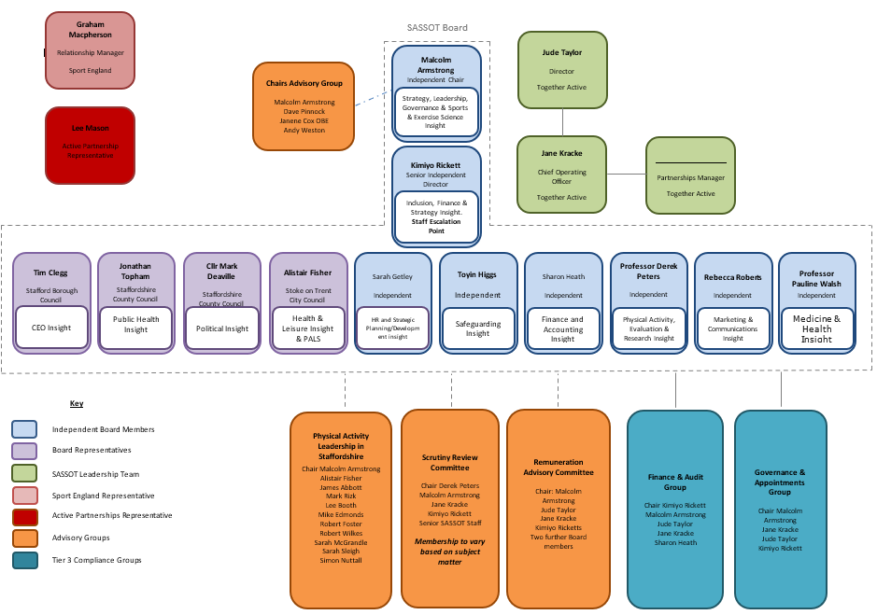

2.5 Diversity in Governance and Leadership

Our Diversity in Governance and Leadership Action Plan was officially signed off by Inclusive Boards on behalf of Sport England in February 2019. A copy can be viewed here.

Progress regarding the number of female and independent Board members is outlined below:

 | As of 31.03.17 | As of 31.03.18 | As of 31.03.19 | As of 31.03.20
Number of members | 11 | 11 | 12 | 12
Female | 3 (27%) | 5 (45%) | 5 (42%) | 6 (50%)
Independent | 3 (27%) | 4 (36%) | 7 (58%) | 8 (67%)

2.6 Sub-Groups

The Board currently has five sub-groups, as illustrated above, as well as one time-limited working group.

2.6.1 Physical Activity Leadership in Staffordshire (PALS)
- Following a review of SLCOF (Staffordshire Leisure and Culture Officers Forum) in 2018-19, the first meeting of PALS took place in July 2020 and initial key work areas were agreed.
- This is attended by the Heads of Service (or other strategic lead) of each District or Borough Local Authority
- The group is chaired by the Chair of the Board

2.6.2 Scrutiny Review Committee
- This was proposed as a replacement for the Strategy Advisory Group, although it has yet to meet
- It was agreed that the Strategy Advisory Group had run it’s course, as the strategy is now in place and the initial PMIF (Performance Management and Improvement Framework) process has been completed
- This group will scrutinise a different area of operations / delivery on a quarterly basis, with membership changing depending on which Board members feel they have expertise in each area.

2.6.3 Remuneration Advisory Committee
- This was established during 2019-20 and has met once, with the input of an HR advisor, to discuss salary benchmarking and performance management

2.6.4 Finance and Audit Group
Key work areas during 2019-20 include:
- Ongoing updating and monitoring of the 5-Year Financial Forecast
- Ongoing monitoring of income / expenditure against the annual budgets
- Full revision of the organisation’s Risk Register and Risk Management Policy
- An additional Board member joined the group, following recommendations from the Effectiveness Checklist completed towards the end of 2018-19
- A Reserves Policy was written for Together Active, and was approved by the Board 21.01.20

2.6.5 Governance and Appointments Group
Key work areas during 2019-20 include:
- Overseeing the work of the consultants appointed to investigate whether independence is the right option for SASSOT
- Analysis of results of Board Effectiveness / Self-Review survey
- Review of sub-groups, ensuring they remain fit-for-purpose
- Recruitment process for two new Board Trustees

2.6.6 Independence Working Group
- This time-limited group was established following the Board’s decision to become an independent charity
- Meeting monthly, the group is responsible for overseeing the Independence Project Plan and has delegated responsibility for making operational decisions regarding independence

Terms of reference and minutes from each sub-group can be found here.

2.7 Remuneration of Board Members
As outlined in SASSOT’s constitution, the role of Board members is voluntary and no Board members shall receive any remuneration other than reasonable out of pocket expenses.

- Performance Management and Evaluation Framework (PMIF)

3.1 Improvement Plan
Using the feedback from the PMIF self-assessment and formal assessment, which SASSOT underwent during Autumn 2018, an Improvement Plan was drawn up and signed off by Sport England at a ‘Round Table’ meeting in March 2019.

The three strategic priorities for 2019-20 as identified in the Improvement Plan are:
- Become more effective at measuring and demonstrating impact
- Improve understanding and ownership of our strategy and the Place Based Approach
- Enhance SASSOT’s reputation locally and nationally through sharing our learning and successes

Key work to address these priorities includes:
- Finalising our Services Offer document
- Commissioning an Evaluation Framework for use by SASSOT and partners
- Delivery of several knowledge-sharing sessions for partners

- Strategy

  - Introduction
SASSOT’s strategy covers the period 2018-21.

At its heart is an unwavering focus on the needs of our most inactive communities. Working at this locality level will allows us to understand the motivations, barriers and behaviours of residents in those places. Working with partners we aim to address these local issues and turn the dial on inactivity, ensuring every resident can enjoy the economic, social and health benefits of an active lifestyle

  - Strategy Overview

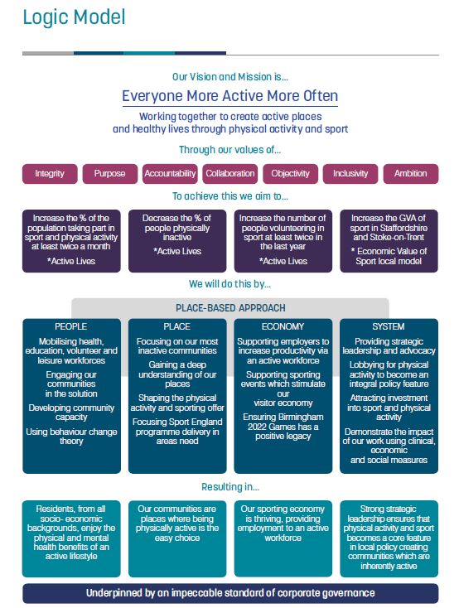

A copy of our full Strategy can be found here

- 2019-20 Delivery
A copy of SASSOT’s annual report for 2019-20 can be found here

A more detailed account of the team’s work can be found in the Annual Delivery Plan, and in our quarterly Dashboards, which provide Board members with a quick visual aid to measure progress against our strategy. Quarterly Annual Delivery Plan updates and Dashboards are include in each Board Meeting’s papers and can be found here.

- Finance

  - Annual Accounts
SASSOT’s Reserves Statement for 2019-20 can be found below:

Annual | Budget (£) | Actual (£)
Carry Forward from 18-19 | (469,603) | (469,596
Income | (640,390) | (699,877)
Expenditure | 737,633 | 615,973
Net Carry Forward to  20-21 | (372,360) | (553,500)
Of which Restricted Funds | (56,950) | (161,843)
Of which Unrestricted Designated Funds | (179,090) | (135,031)
Of which Unrestricted Free Funds | (136,320) | (256,626)

- The Restricted Carry Forward includes the receipt of grants during 2019-20 where partial delivery will take place during 2019-20.
- The Unrestricted Designated Carry Forward is the amount needed to cover our liabilities as of 31.03.20
A copy of SASSOT’s full accounts is available on our website here.
6.2 Five-Year Financial Forecast
Throughout 2019-20, the Five-Year Financial Forecast was updated and adjusted to take into account confirmed funding, staff changes etc. This was monitored by the Finance and Audit Group, and various versions can be viewed with the Board Meeting papers here.

Due mainly to the decision to become an independent charity, it is now forecast that SASSOT / Together Active will end the 2023-24 financial year with all its liabilities covered and with additional unrestricted reserves.

- Independence

  - Overview
SASSOT’s hosting arrangement with Stafford Borough Council has been a positive and value-for-money arrangement for SASSOT over many years. We have benefitted significantly from being able to utilise the services and expertise of Stafford BC’s various departments as part of our all-inclusive hosting arrangement.
However, with all members of the SASSOT team being employed by Stafford Borough Council under Local Government terms and conditions, our on-costs are increasing substantially year-on-year and as of 31.03.19 we were forecast to will end 2021-22 with a significant deficit.

  - Action
Given the above figures, the Board agreed to investigate whether there is a potential cost saving by establishing SASSOT as an independent organisation and, if so, the likely scope of this saving and the implications of realising this saving on both the team and the organisation as a whole.

To support this process, SASSOT secured funding from Sport England to engage a consortium of consultants. During the first three months of 2019-20 they consulted with staff and investigated TUPE considerations / confirmed that Best Value Directions wouldn’t apply to SASSOT. They then took a report to the Board on 16.07.19, outlining their findings and identifying the potential cost savings and additional costs associated with independence.
The Board took the decision that SASSOT would become an independent charity as of 01.04.20, and the Independence Working Group, consisting of Board members, Senior Leadership and a staff representative, was set up to oversee this work.

The name ‘Together Active’ was chosen and was registered with the Charity Commission as a Charitable Incorporated Organisation on 13.01.20. The majority of Board members agreed to transfer to be trustees of the new organisation, and a further two trustees were recruited to bring the Board to it’s full quota of 12 members and to address skills gaps that had been identified.

Due to challenges with identifying a new office base, the move was eventually delayed to 01.05.20, then subsequently moved back to 01.09.20 when the pandemic hit and lockdown began.

- Risk Register and Risk Management Plan

The Finance and Audit Group (FAG) reviews SASSOT’s risk register and Risk Management Plan on a quarterly basis, with any amendments being taken to the Board for approval. Copies of the Register / Plan can be found within the Board Meeting papers here.

The following three key risks remain a priority and actions have been agreed to mitigate them:
- Lack of Financial Sustainability
- Non-Delivery of Agreed Outcomes
- Ineffective Performance Management

