Recruitment

- The winning team from each district inter-school competition will qualify for the county final where their scores will be compared against the highest scoring schools from across the County. Closing date is Friday 25th June

Eligibility

- Pan-disability- open to all SEN students
- Boys & Girls in Year 3 to 6 for the KS2 competition
- Boys & Girls in Years 7-11 for the KS3/4 competition

Team RequirementsVirtual Boccia
KS2 SEN Competition
KS3/4 SEN Competition
Inter-School Competition

- Each child will score individually, each individual score will be the total score from all 3 mini-activities.
- Each school team should consist of 3 children and the teams will be created from the 3 highest scoring children

Competition Format

- The competition will be made up of 3 mini activities. Rules for each event are below.
- Whilst boccia is an indoor sport, the challenges can be performed indoor or outdoor.
- This can be completed in school or at home.
- The highest scoring school team in each District will go through to a virtual County Final where their scores will be compared against the highest scoring schools from across the County.

Equipment requirements
- All players must be seated during each activity.
- Boccia balls, bean bags or screwed up paper balls can be used.
The Events and Rules
Participants will take part in all 3 challenges and score as many points as they can.
The recording sheet enable 3 attempts per child to be imputed and the sheet will select the best score
- A ‘ball’ can be propelled by rolling, throwing or kicking.
- If a player is unable to throw or kick it, they can use a ‘ramp’ (assistive device).
- All players must be seated during the game.

Recording Times/Distances

- You will need to in input identifiable names (GDPR SGO s should not receive results sheets with full names)
- Complete the results sheet fully and email it back to your SGO.
- You can include all results or just the top 3- but please let us know how many children took part!

Challenge 1: Boccia Big Break

- Place 7 numbered (1-7) markers (suggest A5 sheets of paper) on the floor (as shown in the picture) in a style similar to Snooker. If you’re feeling artistic you can colour the paper similar to Snooker balls.
- Set a chair 2metres away as your throwing line.
- There is a picture attached showing the layout (or my attempted diagram below)
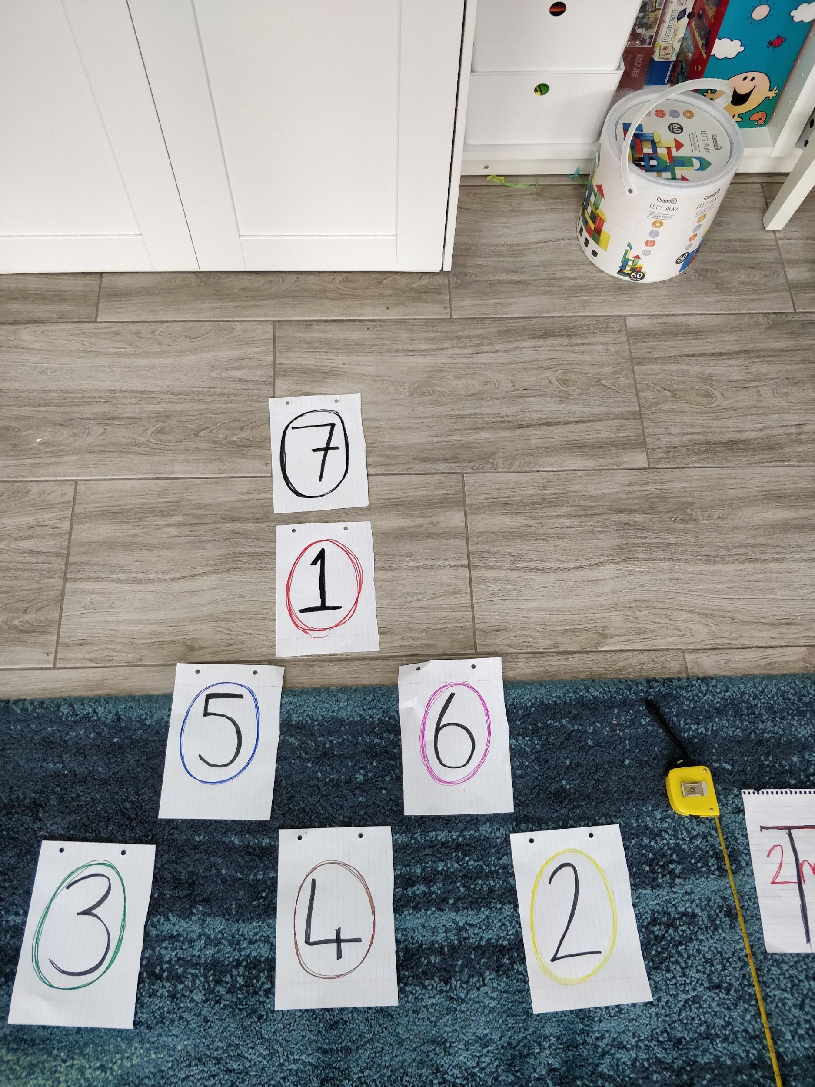
- chair
- 2metres
- 2 (yellow) 4 (brown) 3 (green)
- 5 (blue) 6 (pink)
- 1 (red)
- 7 (black)

- With 5 bean bags/socks/rolled up balls of paper score as many points as you can, by throwing each bag to land on a marker.
- The first piece of paper you hit is the scoring shot. you can hit the same piece of paper more than once.
- Each marker is worth the corresponding number of points.
- Max possible score 35.

Challenge 2: Flip it

- Lay a series of markers 1 meter apart in a straight line, with the first 2m from the throw line.
- Place a hoop between the first 2 markers (see picture)
- With 5 bean bags/socks/rolled up balls of paper score as many points as you can, by throwing each bag to land in the hoop. Every time you land a ball/bag in the hoop flip the hoop over to between the next 2 markers.
- You cannot move the hoop until you land in it.
- The first hoop is worth 6, the next is 7 up to 10.
- Max possible score is 40.

Chair

Challenge 3: Space Invaders

- Lay a series of 15 cones or markers 2 metres from a throwing line (See diagram below).
- Using 3 bean bags/tennis balls/boccia balls you have 1 minute to throw and hit as many of the markers as possible, every time you hit a marker- remove it.
- After throwing all 3 balls- collect them in. If working with a partner they can remove cones and collect balls in.
- Only the first marker a ball hits counts
- The first row of cones/markers each score 1 point
- The second row scores 3 points each
- The 3rd row scores 5pts each

2m 50cm 50cm

Chair

- Max Score is 45pts

County Final Progression

Recruitment

- The winning team from each inter-school competition will qualify for the County final.
- In total there should be a maximum of 10 schools competing representing each of their SGO Areas.

Reward
Winners, runners up and third place will receive medals

