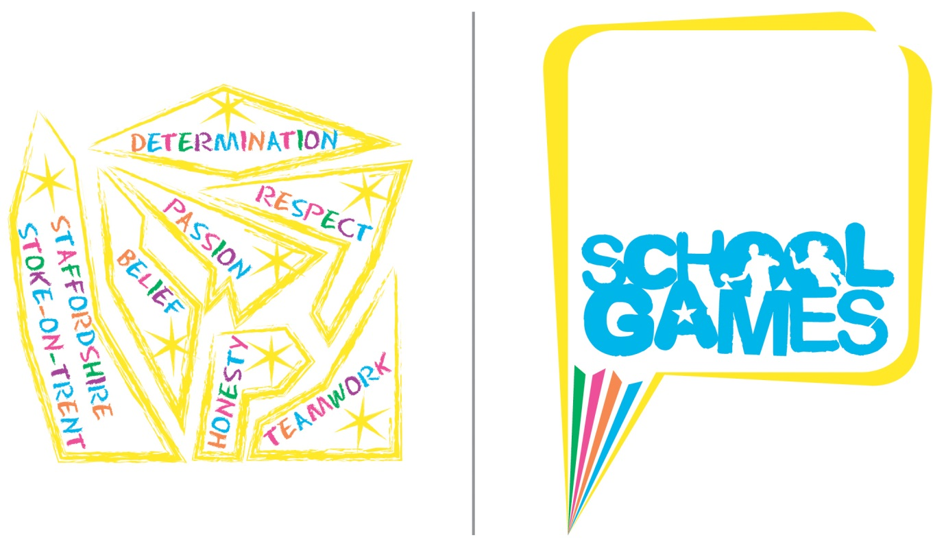
School Games Overview
Staffordshire & Stoke-on-Trent
School Games
Formats
2021/22
(Please note this is a working document and new activities may be added during the academic year)

What is the mission?
Putting physical activity and competitive sport at the heart of schools and providing more young people with the opportunity to compete and achieve their personal best.

What is the vision?
The School Games will continue to make a clear and meaningful difference to the lives of even more children and young people.

During 2021-2022 School Games continues to evolve. For competition to be meaningful and engage more and different young people, it needs to be planned with intention.
Below you will find a table containing all County Finals and Festivals for School Games in Staffordshire. The table also includes the intent behind each event.
Contents

General Information – Page 5
Codes of Conduct – Page 5-7
Sport | Page | Intent
Sportshall Athletics (Year 3/4) | 8-9
Sportshall Athletics (Year 5/6) | 10-12
Sportshall Athletics (Year 7 Boys & Girls and Year 8 Boys & Girls) | 13-14
Covid-19 - Page 8

Summer Festival- Friday June 24th - Keele University
Sport | Page | Intent
Cross Country (Year 3 & 4) | 15-16
Cross Country (Year 5 & 6) | 17-18
Commonwealth Games Girls Festival (Year 9 & 10) | 19
Commonwealth Games Boys Festival (Year 9 & 10) | 19
Dodgeball (Year 8) | 20-22
Quidditch (Year 5 & 6) | 23
Rounders (Year 7 & 8) | 24-25
Sport4All (Soft Archery, Athletics, Boccia and New Age Kurling. Year 3-6) | 26-28

Virtual Activities
Sport | Page | Intent
Virtual Pentathlon (Sportshall Athletics Virtual Event) | 29-31
#BeattheBaton Commonwealth Games Virtual Challenge | 32 | TBC

General Information

Please note the following:

If a school qualifies for a County event but is unable to attend, the next best placed school from the same School Games district from their qualifying competition will be invited to attend instead. If this school is unable to attend, then next best placed school will be invited etc.

If the number of teams is identified as likely to be significantly lower than the maximum for any of the County finals then either of the following may happen depending on the number of spaces available:

- All SGOs who are able to enter a team may be invited to enter an additional team.
- One or more SGO’s able to enter a team may be invited to enter an additional team – SGO’s will be selected randomly. The decision regarding which of these options to use will be made by the relevant tournament co-ordinator.

Codes of Conduct

Participants

- I will treat others with the same respect and fairness that I would like them to show to me.
- I will play within the rules, and respect officials and their decisions.
- I will demonstrate fair play on and off the field.
- I will respect others regardless of gender, disability, race, ethnicity, and religious belief.
- I will not accept any behaviour that discriminates against others.
- I will not engage in any irresponsible or illegal behaviour e.g. smoking, consuming alcohol, or drugs.
- I will inform my team manager if I need to leave my team at any time.
- I will inform an adult if I am concerned, or if I feel uncomfortable.
- I will be organised and on time.
- I will take part and try to make it a happy atmosphere for everyone.

Anyone deemed breaching these codes of conduct can be immediately disqualified from the competition, and if necessary, asked to leave.

Sports Co-ordinators, Volunteers, Teachers and Other Adults working at the Games

As a Sports Co-ordinator, volunteer, teacher or other adult working at this year’s School Games we ask you to acknowledge the ethos of the Games, and to read the guidelines and adhere to them with professionalism and appreciation for what they mean. Anyone deemed breaching the codes of conduct will face further action. After an initial warning has been given this may result in any of the following; a letter to your head teacher, letter to the Chair of Governors and / or being asked to leave the competition. Any action taken post-competition will be decided and enforced by the Active Partnership and School Games Organisers.

Consistently display high personal standards and project a favourable image of your sport:
- Adhere to the rules of the game and the tournament.
- Minimise the ‘side-line antics’.
- Support the referees and their decisions.
- Referees – especially young and inexperienced ones –need time to develop. You can play an important role in helping them to improve by letting them concentrate on the game.

Refrain from the use of profane, insulting, harassing or otherwise offensive language:

- The referees are there to facilitate the games, not to be argued with or to receive comments from coaches, players or third parties.
- The School Games provide an excellent opportunity for youngsters to get involved in structured coaching and experience a competitive environment, however the underlining message, the legacy if you like, should always be one of ‘Fair play’, ‘Sportsmanship’ and ‘Participation’, a responsibility that is shared by all those involved in the organisation of the event.
- Those involved in running the Games should abstain from and discourage the use of drugs, alcohol and tobacco products in conjunction with sport.

Treat everyone fairly:
- Encourage fair play across the teams by their players.
- Respect the rights, dignity and worth of every human being.
- Within the context of the activity, treat everyone equally regardless of gender, disability, ethnicity or religion.
- Within the limits of your control, ensure as far as possible the safety of all the performers with whom you work.
- Co-operate with the players’ parents or legal guardians.
- The competitions and the Games rely on efficient and positive co-operation from all those involved in running the event.

Officials

- Place the safety and welfare of the participants above all else.
- Modify rules and regulations, where appropriate, to match the skill levels and needs of the young people taking part.
- Compliment and encourage all participants.
- Be consistent and objective when making decisions.
- Promote respect amongst participants.
- Always emphasise the spirit of the game.
- Encourage and promote rule changes, where appropriate, that will make participation more enjoyable for the participants.
- Be a role model, actions speak louder than words.
- Keep up to date with the latest developments in officiating and the principles of growth and development of young people.
- Your behaviour and comments should always be positive and supportive unless condemning unsporting behaviour.
- Behave responsibly. Discriminatory, offensive and violent behaviour towards any individual is unacceptable and will be acted upon.
- Respect the rights and dignity of every young person

Spectators

- Remember that young people participate in sport for their enjoyment and benefit, not yours.
- Acknowledge good performances from all individuals and teams.
- Congratulate all participants on their performance, regardless of the game’s outcome.
- Respect the decisions of officials and teach young people to do the same.
- Never ridicule a young player for making a mistake. Positive comments are always motivational.
- Condemn the use of violence in any form, whether it is by other spectators, sports co-ordinators officials or players.
- Show respect for your team’s opponents. Without them, there would be no game.
- Encourage all players to follow the rules and the officials’ decisions.
- Do not use foul language or harass players, coaches or officials.
- Behave responsibly. Discriminatory, offensive and violent behaviour towards any individual is unacceptable and will be acted upon.
Respect the rights and dignity of every young person.

Anyone deemed breaching these codes of conduct will be given an initial warning and may be asked to leave the site.

COVID-19
We will adhere to government guidance related to COVID-19 that is current at the time of the event, and we require schools to follow any government guidance that is in place at the time too. We also ask that schools do not let any pupils with symptoms of COVID-19 attend the event (i.e., a new, continuous cough, a high temperature or loss or change to sense of smell or taste). We also ask schools to inform spectators with their school of the above. If this means that your school is no longer able to take part, then please contact the Event Manager as soon as possible:

Event Manager
Camilla Denham-White
07772223059
Camilladenham-white@togetheractive.org
Sportshall Athletics
Year 3 & 4
Thursday 17th March 2022
Fenton Manor Sports Complex, Stoke-on-Trent

Recruitment

- The winning team from each Inter-School competition will qualify for the County final.
- If the Inter-School competition format used by an SGO is not the same as the format that will be used at County final, the SGO is responsible for ensuring that their school that qualifies for the County Small Schools final is fully aware of the County format / requirements.

Eligibility

- The competition is for pupils in Years 3 and 4 for the academic year 2021-22.

Team Requirements

- Teams should consist of six boys and six girls.
- Each pupil can compete in a maximum of two track and two field events, taken from the list below.

Player Requirements

- Pupils will not be able to compete in bare feet or unsuitable footwear.

Pitch / Playing Area Requirements

- 8-court sportshall.

Events

The events are:

Track  1 + 1 Lap Relay (2 girls and 2 boys)  2 + 2 Lap Relay (2 girls and 2 boys)  Obstacle Relay (4 girls and 4 boys)  4 x 1 Lap Relay (4 girls and 4 boys) | Field  Chest Push (2 girls and 2 boys)  Five Strides (2 girls and 2 boys)  Soft Javelin (2 girls and 2 boys)  Speed Bounce (2 girls and 2 boys)  Standing Long Jump (2 girls and 2 boys)  Vertical Jump (2 girls and 2 boys)

Competition Format and Rules

Please click on the link below for the formats:

Microsoft Word - Primary Rules and Guidance Notes_17 Y3&4.docx (sportshall.org)

Please note- the County Final will only feature the track and field events in the table above and not all of the ones featured in the link above.

Additional Information
- Team Managers should bring completed team sheets to the event (these do not need to be submitted beforehand).
- Your local SGO will send this sheet to you.

Progression

- No progression from the County event.

Sportshall Athletics

Year 5 & 6 Large and Small Schools
Tuesday 1st March 2022
Fenton Manor Sports Complex

Recruitment

- The winning team from each Inter-School competition will qualify for the Large Schools County final.
- If a small schools Inter-School competition is held, the winning team will qualify for the Small Schools County final.
- If no separate event is held, the best-placed Small School from each Inter-School competition will qualify for the Small Schools County final.
- If the format used by an SGO is not the same as the format that will be used at County final, the SGO is responsible for ensuring that their school that qualifies for the County final is fully aware of the County format / requirements.

Eligibility

- The definition of a ‘small school’ is a school with less than 45 pupils on the school roll across Years 5 and 6 together (for the current academic year).
- The competition is for pupils in Years 5 and 6 for the academic year 2021-22.
- If necessary to ensure a complete team, schools entering the Small Schools event only can include pupils from Year 4.

Team Requirements

Small Schools
- Teams should consist of six boys and six girls.
- Each pupil can compete in a maximum of two track and two field events, taken from the list below.

Large Schools:
- Teams should consist of a minimum of nine boys and nine girls, with a maximum of 15 boys and 15 girls allowed.
- Each pupil can compete in a maximum of two track and two field events, taken from the list below.

Player Requirements

- Pupils will not be able to compete in bare feet or unsuitable footwear.

Pitch / Playing Area Requirements

- 8-court sportshall.

Events

Small Schools

The events are:

Track  1 + 1 Lap Relay (2 girls and 2 boys)  2 + 2 Lap Relay (2 girls and 2 boys)  Obstacle Relay (4 girls and 4 boys)  4 x 1 Lap Relay (4 girls and 4 boys) | Field  Chest Push (2 girls and 2 boys)  Soft Javelin (2 girls and 2 boys)  Speed Bounce (2 girls and 2 boys)  Standing Long Jump (2 girls and 2 boys)  Standing Triple Jump (2 girls and 2 boys)  Vertical Jump (2 girls and 2 boys)

Large Schools

The events are:

Track  1 + 1 Lap Relay (2 girls and 2 boys)  2 + 2 Lap Relay (2 girls and 2 boys)  6 Lap Paarlauf (2 girls and 2 boys)  Obstacle Relay (4 girls and 4 boys)  Over / Under Relay (4 girls and 4 boys)  4 x 1 Lap Relay (4 girls and 4 boys) | Field  Chest Push (3 girls and 3 boys)  Soft Javelin (3 girls and 3 boys)  Speed Bounce (3 girls and 3 boys)  Standing Long Jump (3 girls and 3 boys)  Standing Triple Jump (3 girls and 3 boys)  Vertical Jump (3 girls and 3 boys)

Competition Format and Rules
Please see the following weblinks for formats:

- Small Schools:
http://sportacrossstaffordshire.co.uk/wp-content/uploads/2016/09/School-Games-Sportshall-Athletics-Event-Format-Small-Schools.pdf
- Large Schools:
http://www.sportshall.org/primary/primary-sportshall/primary-sportshall-competition/teachers-downloads?menu-item=menu-item-471

Additional Information
- Team Managers should bring completed team sheets to the event (these do not need to be submitted beforehand). These can be downloaded from here:

- Small Schools:
http://sportacrossstaffordshire.co.uk/wp-content/uploads/2016/09/School-Games-Sportshall_Primary_Teamsheets_Small_2013.pdf
- Large Schools:
http://www.sportshall.org/primary/primary-sportshall/primary-sportshall-competition/teachers-downloads?menu-item=menu-item-471

Progression

- No progression from the County event.

Sportshall Athletics
Year 7 Boys & Girls and Year 8 Boys & Girls
Tuesday 1st March 2022
Fenton Manor Sports Complex, Stoke-on-Trent

Recruitment

- The winning team from each Inter-School competition will qualify for the County final.

Eligibility

- This consists of four separate competitions: Yr 7 boys, Yr 7 girls, Yr 8 boys, Yr 8 girls.
- Teams must consist purely of pupils from within the stated year group / gender.

Team Requirements

- Teams should consist of a minimum of five and a maximum of eight athletes.
- Each pupil can compete in a maximum of three track and two field events, taken from the list below.
- Team Managers are encouraged to note the running order of events (see below) and select their team accordingly:
  - It is inappropriate for an athlete to contest both the 2 and 4 lap Individual Races or the 6 lap and 8 lap Paarlauf events since they follow immediately. There are fewer problems associated in contesting field events in the same group and additional time will be permitted for athletes covering two events in the field.

Player Requirements

- Pupils will not be able to compete in bare feet or unsuitable footwear.

Pitch / Playing Area Requirements

- 8-court sportshall.

Events
- The events are:
Track  2 Lap Individual Race (2 athletes)  4 Lap Individual Race (2 athletes)  8 Lap Paarlauf (2 athletes)  6 Lap Individual Race (1 athlete)  Obstacle Relay (4 athletes)  4 x 2 Lap Relay (4 athletes) | Field  Shot (2 athletes)  Speed Bounce (2 athletes)  Standing Long Jump (2 athletes)  Standing Triple Jump (2 athletes)  Vertical Jump (2 athletes)

Competition Format

Please see the following web links for event formats:

http://www.sportshall.org/wp-content/uploads/2013/06/Sportshall_Secondary_School_Pack_13.pdf

- For the secondary event, the ‘boys and girls double age-group match’ format will be used.

Rules

- Please see the following weblinks for event formats:

https://www.sportshall.org/wp-content/uploads/2013/06/Secondary_Rules_and_Guidance_Notes_19.pdf

- For the secondary event, the ‘boys and girls double age-group match’ format will be used.

Progression

- No progression from the County event.

Additional Information

- Team Managers should bring completed team sheets to the event (these do not need to be submitted beforehand). These can be downloaded from here:

http://www.sportshall.org/wp-content/uploads/2013/06/Sportshall_Secondary_Teamsheets_13.pdf

Cross Country
Year 3 & 4
Summer Festival

Recruitment

- The winning team and runner up from each Inter-School competition will qualify for the County final.
- Individual Entry- Where an individual athlete finishes in 1st place at the Inter School Competition and their team does not qualify for the County Final, the athlete will be offered a place to go to the County Final as an individual to compete in the main race.

Eligibility

- Boys & Girls in Year 3.
- Boys & Girls in Year 4.

Team Requirements

- Each boys team should consist of 4 boys.
- Each girls team should consist of 4 girls.

Clothing and Equipment Requirements

- All competitions will be held outdoors on grass, so pupils will need to bring clothes appropriate to the weather. Warm and waterproof clothing is recommended. Pupils are permitted to wear spikes and should wear these if available.

Pitch / Playing Area Requirements

- Playing field type area based around Keele University.

Competition Format

- Year 3 competition will compete over 600m.
- Year 4 competition will compete over 800m.
- Teams will be made up of 4 boys or 4 girls.
- There will be 4 separate races
  - Year 3 boys race
  - Year 3 girls race
  - Year 4 boys race
  - Year 4 girls race

Rules
The 3 best placings from the 4 runners for each team will be used to determine the overall team winner. There will be 1 boys race and 1 girls race for each age group. The main race at the County Final will award individual medals to the top 3 athletes regardless of whether they are competing as part of a team or individually. There will also be medals given to the top 3 teams in each race. An athlete may win more than one medal on the day i.e. individual & team. This will not affect the overall team competition on the day.
Progression

- No progression from the County event.

Cross Country

Year 5 & 6
Summer Festival

Recruitment

- The winning team and runner up from each Inter-School competition will qualify for the County competition.
- Individual Entry- Where an individual athlete finishes in 1st place at the Inter School Competition and their team does not qualify for the County Final, the athlete will be offered a place to go to the County Final as an individual to compete in the main race.

Eligibility

- Boys & Girls in Year 5.
- Boys & Girls in Year 6.

Team Requirements

- Each boys team should consist of 4 boys.
- Each girls team should consist of 4 girls.

Clothing and Equipment Requirements

- All competitions will be held outdoors on grass, so pupils will need to bring clothes appropriate to the weather. Warm and waterproof clothing is recommended. Pupils are permitted to wear spikes and should wear these if available.

Pitch / Playing Area Requirements

- Field area and track at Keele University.

Competition Format

- Year 5 competition will compete over 1200m.
- Year 6 competition will compete over 1600m.
- Teams will be made up of 4 boys or 4 girls.
- There will be 4 separate races
  - Year 5 boys race
  - Year 5 girls race
  - Year 6 boys race
  - Year 6 girls race

Rules
The 3 best placings from the 4 runners for each team will be used to determine the overall team winner. There will be 1 boys race and 1 girls race for each age group. The main race at the County Final will award individual medals to the top 3 athletes regardless of whether they are competing as part of a team or individually. There will also be medals given to the top 3 teams in each race. An athlete may win more than one medal on the day i.e. individual & team. This will not affect the overall team competition on the day.

Progression

- No progression from the County event.
Commonwealth Games Girls and Boys Festival
Summer Festival

1 or 2 schools from each SGO area to attend.

Target Group

Working with 1 or 2 schools from each SGO area, SGO’s and school staff will identify Inactive Year 9/10 Boys and Girls. Particularly but not exclusively those from underrepresented groups such as low socio-economic backgrounds, minority ethnic groups and SEND.

School Requirements

We would like each school attending, where possible, to bring a group of Year 9/10 Boys and/or Year 9/10 Girls with a maximum of 10 of each gender.

Clothing and Equipment Requirements

Some activities will be held outdoors, so pupils will need to bring clothes appropriate to the weather. Warm and waterproof clothing is recommended.

The Process
- Consultation with young people- February 2022
The Active Partnership will be able to support delivery of this. Or alternatively, the SGO can undertake the consultation process themselves or alongside the Active Partnership. There will also be some support from a select group of students from Staffordshire University who have been tasked with a ‘Real World’ project around the consultation process with young people.
- Follow up meeting with young people- April/May 2022
This will be to update the pupils on what will happen at the festival and give them the opportunity to answer any questions. This may not be face to face and could be delivered virtually.
- Schools to attend the Summer Festival- June 2022
This will be for pupils to take part in the Commonwealth Games Festival, pupils must also complete feedback on the day before leaving the event.
- Follow up meeting with young people- September/October 2022
This will be to evaluate whether taking part in the festival has changed the pupils outlook on physical activity. E.g. has it improved their physical activity levels, has their mental health improved etc.

Dodgeball (Year 8 Boys)

Summer Festival

Recruitment

- Teams will qualify for the County final via inter-school competitions.
- Winners only of inter-school competitions will qualify for County finals, unless a ‘double-district’ (two SGO areas) event has been held, in which case the best-placed school from each SGO area will qualify for the County final.
- In total there should be a maximum of 10 schools competing in the County final.

Eligibility

Boys must be in Year 8 only.

Team Requirements

6 players on a team with a maximum squad size of 10.

Clothing and Equipment Requirements

Indoor sports clothing and indoor trainers A size 2 Cloth Dodgeball should be used (https://britishdodgeball.org/product/official-size-2-cloth-dodgeball/)
Competition Format
- The competition will be played in a round robin format with 2 groups.
- This will be followed by semi finals and then a final.
- One game lasts for two minutes. A match is best of three games.
- Match time will be 6 minutes with no half time.
- In group tables, a team will receive 2 points for two points for a match won, one point for a match drawn and zero points for a match lost.
- A match is the best of 3 games in the knock out stages. If a match is drawn in knockout or playoff matches, a 1 minute overtime game will be played where teams restart with 6 players. If a match is still drawn, then sudden death will be played.

Pitch / Playing Area Requirements
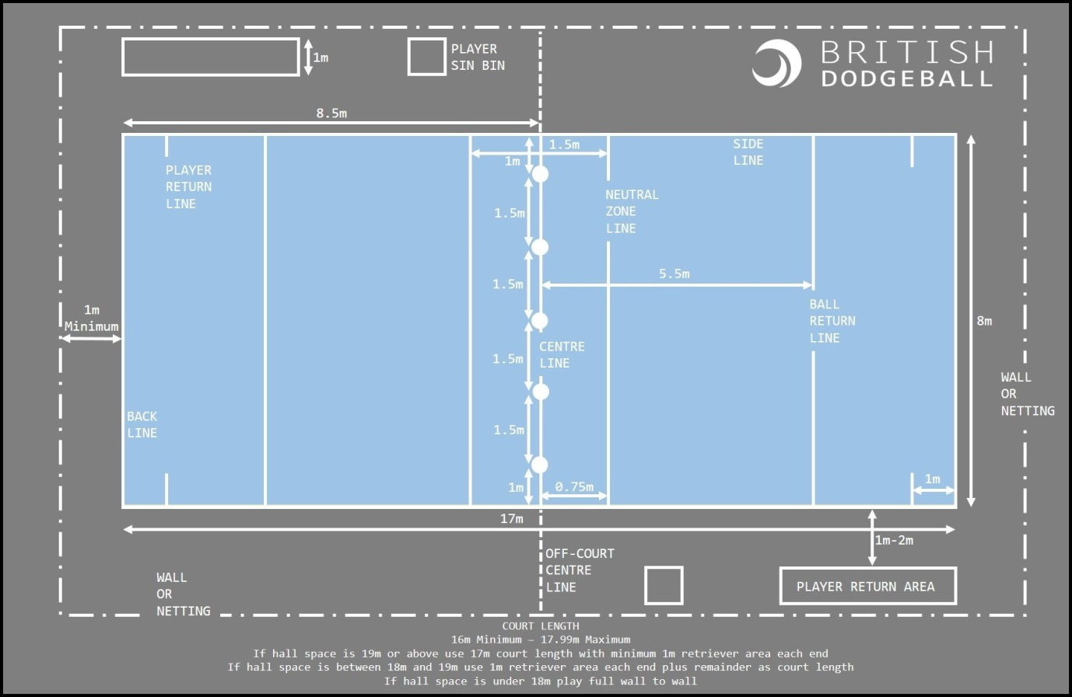

Scoring

- To win a game, eliminate all opposing players or have more players on your side at the end of the game.
- To win a match, you must have more points

Rules

Start of Play

- Start of play- 5 dodgeballs are used and placed along the centre line at the start of each game.
- The 2 balls on a team’s left are their designated balls
- The centre ball is the only contested ball.
- A ball is not live until it is passed back beyond the return line.

Eliminating opposing players

- Live balls- A ball is live until it hits a floor, wall or any other surrounding surface. Multiple play is possible with a live ball.
- Hits- Any player struck with a live ball by an opposing player will be called out. Face shots do not count unless a player’s face stops the ball from hitting their body.
- Catches- Any catch on a live ball will be valid. The player who threw the caught ball will be called out and the catching teams will gain one player from the outbox.
- Blocking- Players are able to use a ball in their possession to block and incoming ball. If the ball they are holding is knocked from their possession, they will be called out.
- Lines- High School dodgeball is played on a dodgeball court. Players are called out for stepping over the side/back lines. Depending on competition type, new players may be warned about line infringements before being called out. Players may leave the court to collect balls by putting their hand up. Players must return to court from behind the back line.
- Stalling- Players should not intentionally stall the game. Once a team has possession of 3, 4 or 5 balls, they should look to make an attempt with at least one of those balls. When a referee calls ‘Play Ball’, a team has 5 seconds to throw. If they do not then players holding balls will be called out. Teams can keep one ball after ‘Play Ball’ has been called, and must throw the rest.
- Multiple Play- The following are examples of multiple play- player will be called out if they are hit by a ball that has deflected off a teammate whilst it is still live. Catch is valid if it has deflected off a teammate whilst it is still live- in this circumstance the hit player plus the thrower will be called out- if the hit player is the first one out, then they will immediately return to the court.

Progression

- No progression from the County final.

Quidditch
Year 5 & 6
Summer Festival

Recruitment
- Each SGO will invite a target primary school from their district- one identified as least engaged in-line with SG minimum expectations.
- 10 children will be invited to attend the event, identified by the school and SGO as less active.

Team Requirements
- Teams can consist of 7- 10 players. All 10 players will take part in the introductory morning session, introducing children to the game of Quidditch. In the afternoon session children will play games of Quidditch. This will involve 7 children playing, with up to 3 substitutes.
- Teams can be mixed or single gender.

Event Format

This event is aimed at being a reward event for Schools engaging in School Games.
In the morning children will learn the game and skills of Quidditch.
In the afternoon schools will play some games against each other.

Quidditch is a fast-paced, mixed-gender sport based on the Harry Potter novels by JK Rowling.

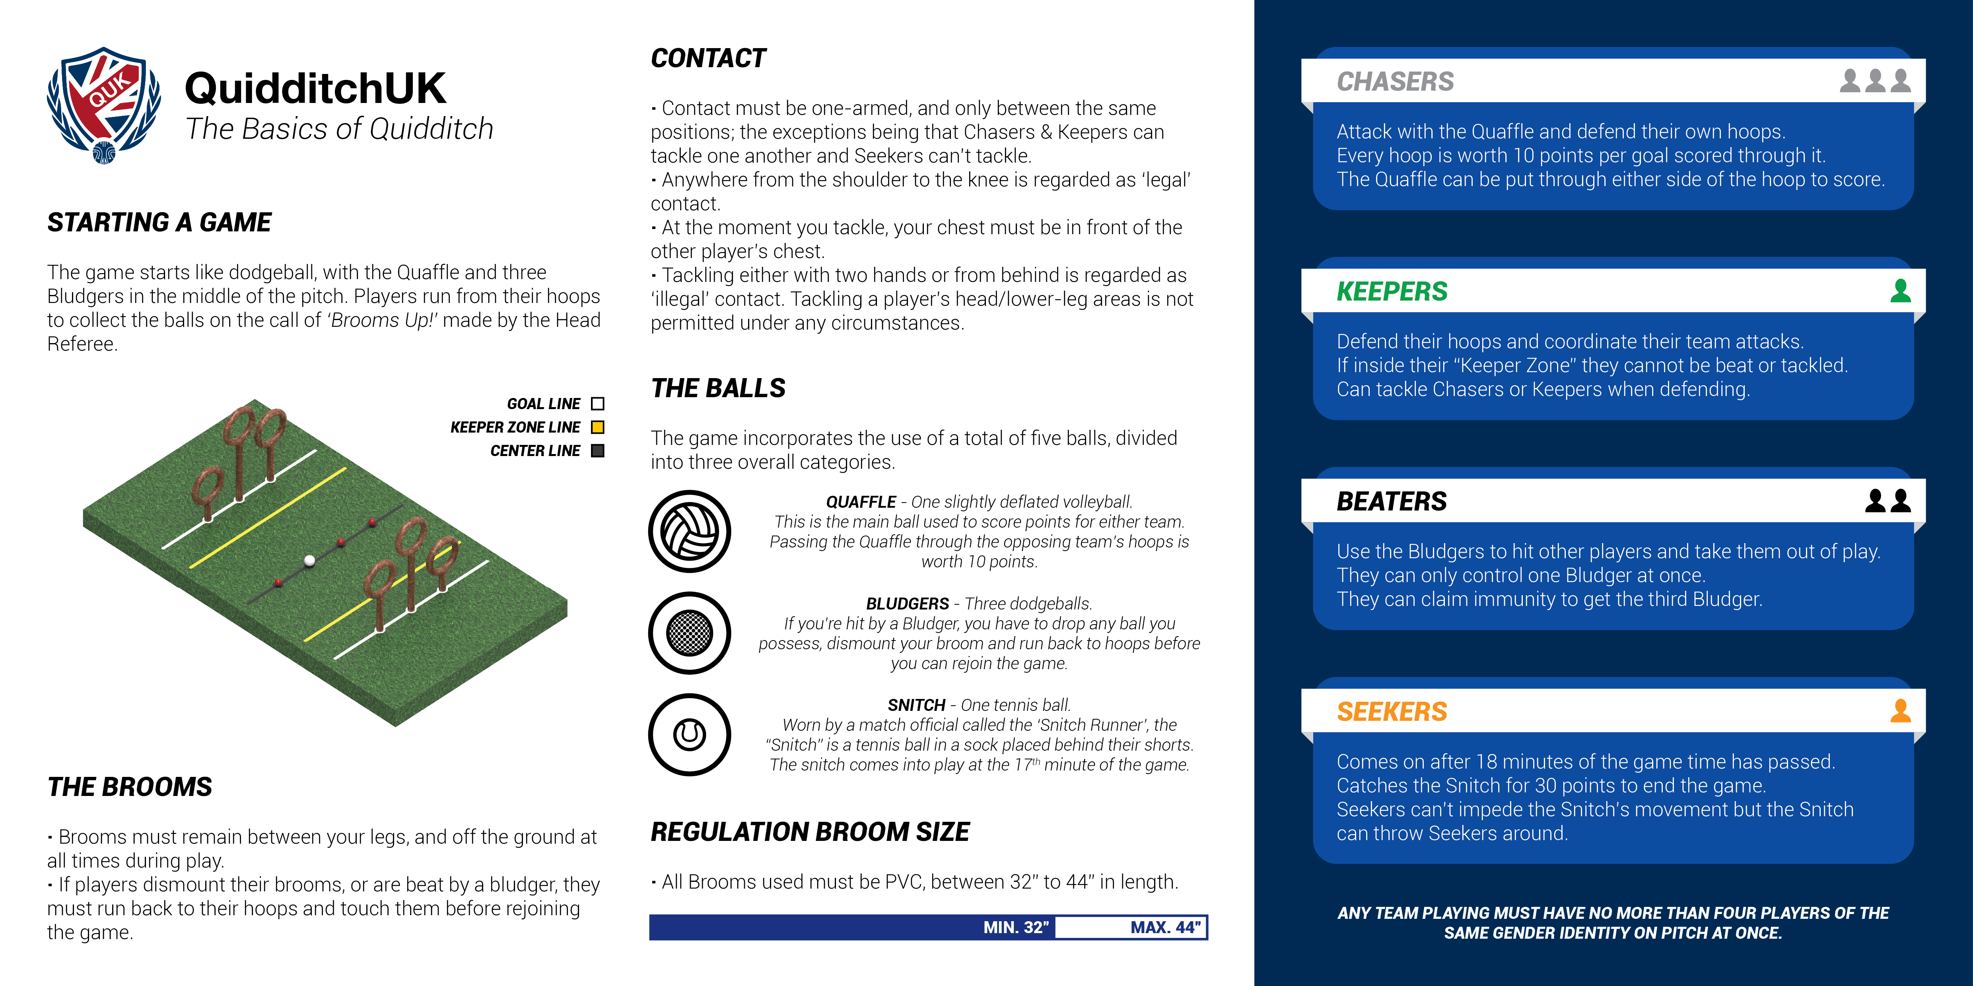
Rounders
Year 7/8 Girls
Summer Festival

Recruitment

- The winning team from each Inter-School competition will qualify for the County tournament.

Eligibility

- Girls must be in Year 7 or 8 only.

Team Requirements

- Maximum of 15 players on a squad and a minimum of 6 players.
- No more than 9 playing on a pitch at any one time.

Competition Format

- Each tournament will have one pool and will be played in a 'round robin' format. 5 points for a win, 3 points for a draw and 0 points for a loss.
- Games to be played over one innings per side, with 15 good balls per innings.
- This may be reviewed depending on the final number of teams in each competition.

Rules

Teams

- Games are played between two teams. See above for team sizes.
- List of players and substitutes should be submitted to the Umpire prior to play
- Players once substituted may return during the game, but batters only in the position of their original number.

Scoring

- 1 Rounder if ball is hit and 4th post is reached and touched before next ball is bowled (if the post ahead of the batter has not been stumped).
- 1 Rounder if ball is hit and 4th post reached on a no ball (you can’t be caught out)
- ½ Rounder if 4th post reached without hitting the ball.
- ½ Rounder if ball is hit and 2nd post reached and touched before next ball is bowled - but if you continue this run and are put out before reaching 4th post, the score will be nullified
- Penalty ½ Rounder for an obstruction by a fielder.
- Penalty ½ rounder for 2 consecutive no balls to same batter.
- 1 Rounder for a backward hit if 4th post reached (you stay at 1st while ball is in the backward area).
- The team with the highest number of Rounders wins.

Running Around the Track

- If you stop at a post you must keep contact with the post, with hand or bat. If you don’t the fielding side can stump the following post to put you out.
- You can run on to a post even if it has been previously stumped (you don’t score if the post immediately ahead has been stumped).
- When the bowler has the ball in his square you cannot move on, but if you are between posts you can carry on to the next.
- You cannot have two batters at a post. The Umpire will ask the first to run on when the second one makes contact.
- At a post you do not have to move on for every ball bowled.
- Once in contact with the post, you may turn the corner over the 2 metre line. If you turn the corner during a run and there is no contact with the post you will be deemed to have turned the corner and must run on.

Out When

- Caught off a good ball.
- Foot over front/back line of batting square before hitting or missing a good ball.
- Running inside post (unless obstructed).
- The post you are running to is stumped.
- You lose contact with post during bowlers action when he has possession in the square.
- You overtake.
- You obstruct (you have right of way on a batter’s normal running track only). You can obstruct verbally.
- Deliberately throw bat.
- Ordered out by the Umpires (for example, you cannot have two batters at a post. The Umpire will ask the first to run on when the second one makes contact).
- Whole team out if the ball pitches in the batting square when there is nobody waiting to bat.

Batter

- Wait in the backward area well away from 4th post.
- If out, wait in the backward area well away from 1st post.
- You will have one good ball bowled to you.
- Batter can use 2 hands.
- No ball if:
  - Not smooth underarm action.
  - Ball is above head or below knee (in batters’ normal stance).
  - Ball bounces on way to you.
  - Is wide or straight at body (in batters’ normal stance).
  - The bowlers foot is outside the square during the bowling action.
  - You can take or run on a no ball, but once you reach 1st post you cannot return. You cannot be caught out, you cannot be stumped out at first post and you score in the normal way.
Progression
- No progression from the County Final.

Sport4All Festival (Soft Archery, Athletics, Boccia and New Age Kurling)
Summer Festival

Recruitment

- Each district will run an Inter-School event and having taken part in all four sports (Soft Archery, Athletics, Boccia and New Age Kurling), two school teams will be selected from each area for the County Final. SGO’s will determine qualification criteria, but the criteria may include:
- Placing at the event
- Following School Games values
- In total, there will be a maximum of 20 schools taking part in the County Final.

Eligibility

- Players must be in year 3, 4, 5 or 6 from each SGO areas’ Primary and Special schools.
- Players must be selected from a school’s “less active” category and/or SEND.

Team Requirements

- Teams should consist of 4 players
- Teams can be mixed or single gender
- Maximum of 3 teams per school at Inter-School events

Pitch / Playing Area Requirements

- The court dimensions for all 4 sports will be within half a badminton court in a 4-court sports hall.
- Archery will take place in a court adjacent to a wall with targets set against the wall. The distance to target is the width of the badminton court, with archers firing from between the tramlines.
- Adapted area markings should be deployed where the above is not available.

Event Format

Teams will draw to play in each sport against random opponents during an allotted period of time. Event organisers will operate central timing throughout with sports leaders officiating.

Soft Archery Requirements/Rules

Inclusive Soft Archery

- Each team will have a bow and 3 soft tipped arrows, and a team target set up opposite them.
- The team decides the order they will shoot.
- Archers will be told when they can begin shooting.
- The first archer from each team shoots three arrows at their teams target.
- Only once all arrows have been shot by all teams will archers BE TOLD to collect their arrows.
- The scores are collated and posted up on a score board.
- The next archer from each team shoots a further three arrows and the scores added to the team’s total.
- Archers will continue to shoot until allocated time runs out. Current archer will finish firing their 3 arrows, so that all teams end having fired an equal amount of arrows.
- Leaders keep the score and record final score at end of the allocated time.
Athletics Requirements/Rules

- A 15m long straight course will be set with a start line and marker cone at the opposite end.
- Athletes run in 2 pairs, one athlete guides and the other wears eyeshades.
- The first pair go on the start signal.
- At the turning point, one of them must touch the cone.
- They return to the start line and the second pair go on a touch handover, the first pair change roles.
- They continue until all 4 have run with eyeshades.
- The time taken for all 4 athletes gives the total team time.

Boccia Equipment Requirements/Rules

- A set of Boccia balls consists of four red, four blue, and one white Jack per game.
- A Boccia ball that is out of play must be placed in a Dead Ball zone so that all competitors can see how many balls are remaining.
- Sports leader officials will indicate which side (red or blue) should play next.
- The aim of the game is to get closer to the jack than your opponent.
- The player to throw the jack ball will follow by throwing their first ball.
- The ball can be propelled by rolling, throwing, kicking or using a ramp.
- All players must be seated during the game on their backside or knees or a wheelchair.
- Teams throw alternately until they run out of balls.
- Once all the balls have been thrown, the side will receive one point for every ball they have closer to the jack than the other team.
- A ball will be considered out of court if it crosses the boundary line.
- Leaders keep the score and record final score at end of the allocated time.
New Age Kurling Equipment Requirements/ Rules

- A set of Kurling stones consists of four red, four blue, and one target per game.
- The aim of the game is to roll the Kurling stones in to the centre of the designated target.
- All players must be seated on backside, knees or in a wheelchair at all times.
- Leaders keep the score to an agreed format and record final score at end of the allocated time.

Progression

No progression from the County event.
Virtual Pentathlon (Y3/4, Y5/6, Y7/8G, Y7/8B)

Recruitment

- This competition is open entry and SGO’s will make a local decision as to whether submit results for their area.
- Results need to be submitted by Friday 27th May 2022
Team Requirements

Top 3 Boys and Top 3 Girls in each category-
Y3/4 Mixed
Y5/6 Mixed
Y7/8 Girls
Y7/8 Boys

Events
Standing Long Jump
Speed Bounce
Chest Push
Vertical Jump
10x10m Shuttle run

Event running and Scoring

All 5 activities that make up Pentathlon can be run for a class as individual activities over several days, or as a single session (to run as a single session suggested 1 hour per class/bubble)
scores have been entered onto the spreadsheets the Virtual Competition Team Score will be created.
Each school will enter their scores onto the Virtual Competition Score Spreadsheet (SGO’s to send these out) and this will then generate a team score once all scores have been added.
This score is an accumulation of the Top 3 Boys and Top 3 Girls point scores in each of the 5 selected events (30 points in total) for each group (Y3/4, Y5/6, Y7/8G, Y7/8B). Schools should then send their local SGO this score. SGO’s will then manage a local leaderboard, which will feed into the County Final.
Competition Format
Rules/format for each event below. For diagram of suggested set-up’s please follow link. Your SGO will send out the Virtual Pentathlon score sheet.
https://www.sportshall.org/wp-content/uploads/2021/10/Guidance-Notes-051021.pdf

Standing long jump
• The athlete must stand with both feet behind the take off line.
• Techniques involving a crouch or rocking motion prior to the jump are permitted provided that both feet are alongside each other and retain contact with the mat until the start of the jump.
• The athlete should jump as far as possible from a standing position, with a two footed take off.
• The athlete must land on the mat with both feet. If an athlete’s foot lands outside the graduated area and the judges are able to measure the jump, it should be recorded as a good trial.
• The athlete is not required to hold the landing position and may step forward after the jump. Should the athlete step back, fall back or touch the mat or floor behind their heel, a no jump should be recorded.
• Measurement is taken from the take off line to the back of the closest heel on landing.
• The athlete is permitted 3 consecutive trials.

Speed Bounce
• Speed Bounce is a two-footed jump in which an athlete must take off and land on both feet – the athlete’s feet should leave the mat simultaneously and land on the mat simultaneously.
• A Speedbounce Wedge should be an obstacle 20cm high.
• The athlete should cross the wedge as many times as possible in 20 seconds.
• Any athlete undertaking a trial and considered to be using an incorrect technique should be stopped, provided an explanation and permitted a fresh trial after an adequate rest period.
• The number of “good” bounces should be recorded, i.e. the number of times the athlete completes a two footed jump over the wedge. Whilst any bounce in which the athlete lands on the wedge should not be counted, it is not an offence to clip or brush the wedge.

Chest Push
A standing throw where the participant pushes a 1kg (Primary) or 2kg (Secondary) from the chest.
• The athlete holds the ball to their chest and pushes with both hands. The chest must face forward with no trunk rotation.
• Both feet must be behind the throwing line and remain on the floor at all times. One foot may be in front of the other but no run ups or steps are permitted.
• The athlete must not pass the throwing line during their throw.
• Once thrown, the ball doesn’t have to land on the mat.
• The distance is measured from the throwing line to where the ball lands marked down to the nearest 25cm.
• The athlete is permitted 3 consecutive trials.

10x10m Shuttle run
• The athlete begins from a standing position behind the start line.
• On the whistle the athlete runs 10 metres to the set of cones opposite.
• The athlete must place one foot over the return line before turning and running in the opposite direction.
• After completing the 10 metre distance 10 times the clock is stopped when they re-cross the start line.
• Alternatively a 20 x 5m distance can be completed where indoor space prohibits a 10m course distance..
• The time is taken to the tenth of a second.
• 0.2 second must be added if the athlete turns short of the line.

Vertical Jump
• The athlete stands with their back, head and heels touching the wall.
• Both arms should be stretched upwards to push the sliding scale up with their fingertips. Elbows and fingers must be straight and arms should touch the side of the head. Feet must stay flat on the floor.
• Younger athletes can find it difficult to push the slide up and the judge may assist by raising the slide first and then bringing it down to meet the athlete’s fingertips. The practice of “straightening” an athlete’s arms cannot be permitted. The following practice is recommended:
• The judge should encourage the athlete to stretch to their full extent and then, to stretch again. Usually the second stretch will set the slide a little higher.
• If the judge is not satisfied that the athlete has achieved a full stretch, the athlete should be advised of this and given a further opportunity to set the slide.
• The athlete is given 3 consecutive trials.
• The athlete must dip their fingertips in powder and stand sideways on to the wall with the jumping arm closest to the wall. They then jump from a standing position and touch the scale at the highest possible point.
• An athlete may bend their knees and swing their arms in preparation for the event but their feet must not leave the ground until they take their jump.
• Measurement should be taken to the nearest centimetre below the highest point of the chalk mark on the scale.

County Final

Winning scores will be submitted by those SGO areas who wish to enter and the top 3 schools in each group i.e:

Y3/4 Mixed
Y5/6 Mixed
Y7/8 Girls
Y7/8 Boys

Will receive the following:

1st- Trophy plus gold medals
2nd- silver medals
3rd- bronze medals

Virtual Commonwealth Games #BeattheBaton Challenge for KS2, KS3 & KS4

TBC

