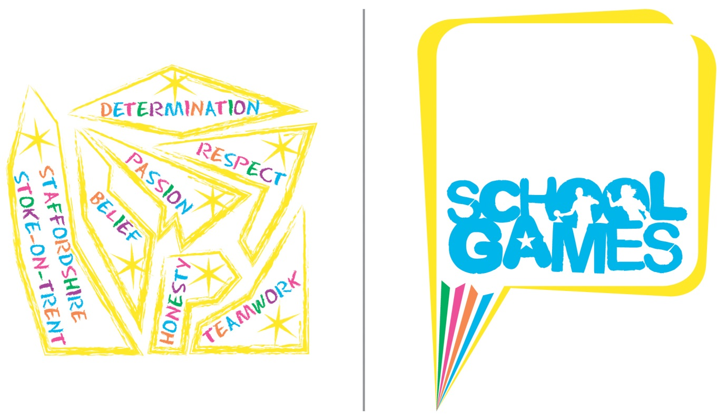
School Games Overview
Staffordshire & Stoke-on-Trent
School Games
Formats
2022/23
(Please note this is a working document and new activities may be added during the academic year- Last Updated 11/5/23)

What is the mission?
Putting physical activity and competitive sport at the heart of schools and providing more young people with the opportunity to compete and achieve their personal best.

What is the vision?
The School Games will continue to make a clear and meaningful difference to the lives of even more children and young people.

During 2022-2023 School Games continues to evolve. For competition to be meaningful and engage more and different young people, it needs to be planned with intention.
Below you will find a table containing all County Events for School Games in Staffordshire and Stoke-on-Trent. The table also includes the intent behind each event.
Contents

General Information – Page 4
Codes of Conduct – Page 4-6
COVID-19 – Page 6

Activity | Page | Intent
Sportshall Athletics (Year 3/4) | 7-8
Sportshall Athletics (Year 5/6) | 9-11
Sportshall Athletics (Year 7 Boys & Girls and Year 8 Boys & Girls) | 12-13
Toughest Challenge | 14
Activity | Page | Intent
Cross Country (Year 3 & 4) | 15-16
Cross Country (Year 5 & 6) | 17-18
Dodgeball (Year 8 Boys) | 19-21
Mini Festival (Year 9 & 10 Boys) | 22
Mini Festival (Year 9 & 10 Girls) | 22
Touch Union Rugby (Year 7 & 8 Girls) | 23
Sport4All (Soft Archery, Athletics, Boccia and New Age Kurling. Year 4 and 5) | 24-26
Summer Festival- Thursday June 22nd - Keele University

General Information

Please note the following:

If a school qualifies for a County event but is unable to attend, the next best placed school from the same School Games district from their qualifying event will be invited to attend instead. If this school is unable to attend, then next best placed school will be invited etc.

If the number of teams is identified as likely to be significantly lower than the maximum for any of the County events then the following may happen depending on the number of spaces available:

All SGOs who are able to enter a team may be invited to enter an additional team.
SGOs will be emailed and given a short but reasonable period of time to confirm they’d like to put forward an additional team (it is expected that the SGO will need to make initial contact with any additional schools to firstly confirm that they would be interested in attending). If there are more additional schools than places put forwards then the school allocated the additional place will be chosen at random.

Codes of Conduct
Participants
- I will treat others with the same respect and fairness that I would like them to show to me.
- I will play within the rules, and respect officials and their decisions.
- I will demonstrate fair play on and off the field.
- I will respect others regardless of gender identity, disability, race, ethnicity, sexuality and religious belief.
- I will not accept any behaviour that discriminates against others.
- I will not engage in any irresponsible or illegal behaviour e.g. smoking, consuming alcohol, or drugs.
- I will inform my team manager if I need to leave my team at any time.
- I will inform an adult if I am concerned, or if I feel uncomfortable.
- I will be organised and on time.
- I will take part for the love of the sport and try to make it a happy atmosphere for everyone.

Anyone deemed breaching these codes of conduct can be immediately disqualified from the competition, and if necessary, asked to leave.

Sports Coordinators, Volunteers, Teachers and Other Adults working at the Games

As a Sports Coordinator, volunteer, teacher or other adult working at this year’s School Games we ask you to acknowledge the ethos of the Games, and to read the guidelines and adhere to them with professionalism and appreciation for what they mean. Anyone deemed breaching the codes of conduct will face further action. After an initial warning has been given this may result in any of the following; a letter to your head teacher, letter to the Chair of Governors and / or being asked to leave the competition. Any action taken post-competition will be decided and enforced by TA.
Consistently display high personal standards and project a favourable image of your sport:
- Adhere to the rules of the game and the tournament.
- Minimise the ‘side-line antics’.
- Support the referees and their decisions.
- Referees – especially young and inexperienced ones –need time to develop. You can play an important role in helping them to improve by letting them concentrate on the game.

Refrain from the use of profane, insulting, harassing or otherwise offensive language:
- The referees are there to facilitate the games, not to be argued with or to receive comments from coaches, players or third parties.
- The School Games provide an excellent opportunity for young people to get involved in structured coaching and experience a competitive environment, however the underlining message, the legacy if you like, should always be one of ‘Fair play’ and ‘Participation’, a responsibility that is shared by all those involved in the organisation of the event.
- Those involved in running the Games should abstain from and discourage the use of drugs, alcohol and tobacco products in conjunction with sport.

Treat everyone fairly:
- Encourage fair play across the teams by their players.
- Respect the rights, dignity and worth of every human being.
- Within the context of the activity, treat everyone equally regardless of gender identity, disability, race, ethnicity, sexuality and religious belief.
- Within the limits of your control, ensure as far as possible the safety of all the performers with whom you work.
- Co-operate with the players’ parents or legal guardians.
- The competitions and the Games rely on efficient and positive co-operation from all those involved in running the event.

Officials
- Place the safety and welfare of the participants above all else.
- Compliment and encourage all participants.
- Be consistent and objective when making decisions.
- Promote respect amongst participants.
- Always emphasise the spirit of the game.
- Encourage and promote rule changes, where appropriate, that will make participation more enjoyable for the participants.
- Be a role model, actions speak louder than words.
- Keep up to date with the latest developments in officiating and the principles of growth and development of young people.
- Your behaviour and comments should always be positive and supportive unless condemning unsporting behaviour.
- Behave responsibly. Discriminatory, offensive and violent behaviour towards any individual is unacceptable and will be acted upon.
- Respect the rights and dignity of every young person regardless of their gender, ability, cultural background or religion.

Spectators
- Remember that young people participate in sport for their enjoyment and benefit, not yours.
- Acknowledge good performances from all individuals and teams.
- Congratulate all participants on their performance, regardless of the game’s outcome.
- Respect the decisions of officials and teach young people to do the same.
- Never ridicule a young player. Positive comments are always motivational.
- Condemn the use of violence in any form, whether it is by other spectators, sports co-ordinators officials or players.
- Show respect for your team’s opponents. Without them, there would be no game.
- Encourage all players to follow the rules and the officials’ decisions.
- Do not use foul language or harass players, coaches or officials.
- Behave responsibly. Discriminatory, offensive and violent behaviour towards any individual is unacceptable and will be acted upon.
- Respect the rights and dignity of every young person regardless of their gender identity, disability, race, ethnicity, sexuality and religious belief.

Anyone deemed breaching these codes of conduct will be given an initial warning and may be asked to leave the site.
COVID-19
There are currently no coronavirus (COVID-19) restrictions in the UK but if government guidance changes then our events will follow this updated guidance.
Sportshall Athletics

Year 3 & 4
Wednesday 22nd March 2023
Fenton Manor Sports Complex, Stoke-on-Trent

Intent

Recruitment

- The winning team from each Inter-School competition will qualify for the County final.
- If the Inter-School competition format used by an SGO is not the same as the format that will be used at County final, the SGO is responsible for ensuring that their school that qualifies for the County Small Schools final is fully aware of the County format / requirements.

Eligibility

- The competition is for pupils in Years 3 and 4 for the academic year 2022/23

Team Requirements

- Teams should consist of six boys and six girls.
- Each pupil can compete in a maximum of two track and two field events, taken from the list below.

Player Requirements

- Pupils will not be able to compete in bare feet or unsuitable footwear.

Pitch / Playing Area Requirements

- 8-court sportshall.

Events

The events are:

Track  1 + 1 Lap Relay (2 girls and 2 boys)  2 + 2 Lap Relay (2 girls and 2 boys)  Obstacle Relay (4 girls and 4 boys)  4 x 1 Lap Relay (4 girls and 4 boys) | Field  Chest Push (2 girls and 2 boys)  Five Strides (2 girls and 2 boys)  Soft Javelin (2 girls and 2 boys)  Speed Bounce (2 girls and 2 boys)  Standing Long Jump (2 girls and 2 boys)  Vertical Jump (2 girls and 2 boys)

Competition Format and Rules

Please click on the link below for the formats:

Microsoft Word - Primary Rules and Guidance Notes_17 Y3&4.docx (sportshall.org)

Please note- the County Final will only feature the track and field events in the table above and not all of the ones featured in the link above.

Additional Information
- Team Managers should bring completed team sheets to the event (these do not need to be submitted beforehand).

Certificates/Medals/Trophies

Certificates will be given to all pupils who participate in the County Final. Medals will be given to the teams that place 1st and 2nd. There will be a trophy awarded to the team that places 1st.

Progression

- No progression from the County event.

Sportshall Athletics

Year 5 & 6 Large and Small Schools
Tuesday 18th April 2023
Fenton Manor Sports Complex

Intent

Recruitment

- The winning team from each Inter-School competition will qualify for the Large Schools County final.
- If a Small Schools Inter-School competition is held, the winning team will qualify for the Small Schools County final.
- If no separate event is held, the best-placed Small School from each Inter-School competition will qualify for the Small Schools County final.
- If the format used by an SGO is not the same as the format that will be used at County final, the SGO is responsible for ensuring that their school that qualifies for the County final is fully aware of the County format / requirements.

Eligibility

- The definition of a ‘small school’ is a school with less than 45 pupils on the school roll across Years 5 and 6 together (for the current academic year).
- The competition is for pupils in Years 5 and 6 for the academic year 2022/23.
- If necessary to ensure a complete team, schools entering the Small Schools event only can include pupils from Year 4.

Team Requirements

Small Schools
- Teams should consist of six boys and six girls.
- Each pupil can compete in a maximum of two track and two field events, taken from the list below.

Large Schools:
- Teams should consist of a minimum of nine boys and nine girls, with a maximum of 15 boys and 15 girls allowed.
- Each pupil can compete in a maximum of two track and two field events, taken from the list below.

Player Requirements

- Pupils will not be able to compete in bare feet or unsuitable footwear.

Pitch / Playing Area Requirements

- 8-court sportshall.

Events

Small Schools

The events are:

Track  1 + 1 Lap Relay (2 girls and 2 boys)  2 + 2 Lap Relay (2 girls and 2 boys)  Obstacle Relay (4 girls and 4 boys)  4 x 1 Lap Relay (4 girls and 4 boys) | Field  Chest Push (2 girls and 2 boys)  Soft Javelin (2 girls and 2 boys)  Speed Bounce (2 girls and 2 boys)  Standing Long Jump (2 girls and 2 boys)  Standing Triple Jump (2 girls and 2 boys)  Vertical Jump (2 girls and 2 boys)

Large Schools

The events are:

Track  1 + 1 Lap Relay (2 girls and 2 boys)  2 + 2 Lap Relay (2 girls and 2 boys)  6 Lap Paarlauf (2 girls and 2 boys)  Obstacle Relay (4 girls and 4 boys)  Over / Under Relay (4 girls and 4 boys)  4 x 1 Lap Relay (4 girls and 4 boys) | Field  Chest Push (3 girls and 3 boys)  Soft Javelin (3 girls and 3 boys)  Speed Bounce (3 girls and 3 boys)  Standing Long Jump (3 girls and 3 boys)  Standing Triple Jump (3 girls and 3 boys)  Vertical Jump (3 girls and 3 boys)

Competition Format and Rules
Please see the following weblinks for formats:

- Small Schools:

https://togetheractive.org/programmes/school-games/county-school-games-events/

- Large Schools:
http://www.sportshall.org/primary/primary-sportshall/primary-sportshall-competition/teachers-downloads?menu-item=menu-item-471

Additional Information
- Team Managers should bring completed team sheets to the event (these do not need to be submitted beforehand). These can be downloaded from here:

- Small Schools:
https://togetheractive.org/programmes/school-games/county-school-games-events/

- Large Schools:
http://www.sportshall.org/primary/primary-sportshall/primary-sportshall-competition/teachers-downloads?menu-item=menu-item-471
Certificates/Medals/Trophies

Certificates will be given to all pupils who participate in the County Final. Medals will be given to the teams that place 1st and 2nd. There will be a trophy awarded to the team that places 1st.

Progression

- No progression from the County event.

Sportshall Athletics
Year 7 Boys & Girls and Year 8 Boys & Girls
Tuesday 18th April 2023
Fenton Manor Sports Complex, Stoke-on-Trent

Intent

Recruitment

- The winning team from each Inter-School competition will qualify for the County final.

Eligibility

- This consists of four separate competitions: Yr 7 boys, Yr 7 girls, Yr 8 boys, Yr 8 girls.
- Teams must consist purely of pupils from within the stated year group / gender.

Team Requirements

- Teams should consist of a minimum of five and a maximum of eight athletes.
- Each pupil can compete in a maximum of three track and two field events, taken from the list below.
- Team Managers are encouraged to note the running order of events (see below) and select their team accordingly:
  - It is inappropriate for an athlete to contest both the 2 and 4 lap Individual Races or the 6 lap and 8 lap Paarlauf events since they follow immediately. There are fewer problems associated in contesting field events in the same group and additional time will be permitted for athletes covering two events in the field.

Player Requirements

- Pupils will not be able to compete in bare feet or unsuitable footwear.

Pitch / Playing Area Requirements

- 8-court sportshall.

Events
- The events are:

Track  2 Lap Individual Race (2 athletes)  4 Lap Individual Race (2 athletes)  8 Lap Paarlauf (2 athletes)  6 Lap Individual Race (1 athlete)  Obstacle Relay (4 athletes)  4 x 2 Lap Relay (4 athletes) | Field  Shot (2 athletes)  Speed Bounce (2 athletes)  Standing Long Jump (2 athletes)  Standing Triple Jump (2 athletes)  Vertical Jump (2 athletes)

Competition Format

Please see the following web links for event formats:

http://www.sportshall.org/wp-content/uploads/2013/06/Sportshall_Secondary_School_Pack_13.pdf

- For the secondary event, the ‘boys and girls double age-group match’ format will be used.

Rules

- Please see the following weblinks for event formats:

https://www.sportshall.org/wp-content/uploads/2013/06/Secondary_Rules_and_Guidance_Notes_19.pdf

- For the secondary event, the ‘boys and girls double age-group match’ format will be used.

Additional Information

- Team Managers should bring completed team sheets to the event (these do not need to be submitted beforehand). These can be downloaded from here:

http://www.sportshall.org/wp-content/uploads/2013/06/Sportshall_Secondary_Teamsheets_13.pdf

Certificates/Medals/Trophies

Certificates will be given to all pupils who participate in the County Final. Medals will be given to the teams that place 1st and 2nd. There will be a trophy awarded to the team that places 1st.

Progression

- No progression from the County event.
Toughest Challenge
Tuesday 4th July 2023
Chasewater Activity Centre, Burntwood

Intent

Recruitment

1 school from each SGO area will be given the opportunity to attend.

Eligibility

- Working with 1 school from each SGO area, SGO’s and school staff will identify 8 pupils to take part.
- Pupils identified must be in Year 8-10
- Those pupils identified will be particularly but not exclusively classed as inactive or from underrepresented groups such as low socio-economic backgrounds, ethnically diverse communities and SEND. They may also have mental health struggles and could be low in self-esteem/confidence.

Clothing and Equipment Requirements

Details can be found in the event manual.

The Process
- Schools will be invited along to a build-up day. The idea is to prepare the pupils for some of the activities they will take part in. They may also get to mix with other pupils and schools.
- Following the Build Up Day, pupils will take part in the Toughest Challenge on Tuesday 4th July 2023.
- Activities that pupils may take part in on the day could include bushcraft, orienteering, climbing. However, this will be led by consultation with pupils in order to co-create the event with them.
- Schools who take part are asked to identify one pupil and track their journey through the project. This could be done as a case study or video etc. The aim is to see what/if the project has made any impact on the pupils life.

Cross Country
Year 3 & 4
Summer Festival

Intent

Recruitment

- The winning team and runner up from each Inter-School competition will qualify for the County final.
- Individual Entry- Where an individual athlete finishes in 1st place at the Inter School Competition and their team does not qualify for the County Final, the athlete will be offered a place to go to the County Final as an individual to compete in the main race.

Eligibility

- Boys & Girls in Year 3.
- Boys & Girls in Year 4.

Team Requirements

- Each boys team should consist of 4 boys.
- Each girls team should consist of 4 girls.

Clothing and Equipment Requirements

- All competitions will be held outdoors on grass, so pupils will need to bring clothes appropriate to the weather. Warm and waterproof clothing is recommended. Pupils are permitted to wear spikes and should wear these if available.

Pitch / Playing Area Requirements

- Playing field type area based around Keele University.

Competition Format

- Year 3 competition will compete over 600m.
- Year 4 competition will compete over 800m.
- Teams will be made up of 4 boys or 4 girls.
- There will be 4 separate races
  - Year 3 boys race
  - Year 3 girls race
  - Year 4 boys race
  - Year 4 girls race

Certificates/Medals/Trophies

- Certificates will be given to all pupils who participate in the County Final.
- The 3 best placings from the 4 runners for each team will be used to determine the overall team winner. Should teams be tied with the result of the first 3 runners of each team then the 4th team members' place/position will determine the result.
- There will be 1 boys race and 1 girls race for each age group. The main race at the County Final will award individual medals to the top 2 athletes regardless of whether they are competing as part of a team or individually.
- There will also be medals given to the top 2 teams in each race. An athlete may win more than one medal on the day i.e. individual & team. This will not affect the overall team competition on the day.
- There will be a trophy awarded to the team that places 1st in each race.
Progression

- No progression from the County event.

Cross Country

Year 5 & 6
Summer Festival

Intent

Recruitment

- The winning team and runner up from each Inter-School competition will qualify for the County competition.
- Individual Entry- Where an individual athlete finishes in 1st place at the Inter School Competition and their team does not qualify for the County Final, the athlete will be offered a place to go to the County Final as an individual to compete in the main race.

Eligibility

- Boys & Girls in Year 5.
- Boys & Girls in Year 6.

Team Requirements

- Each boys team should consist of 4 boys.
- Each girls team should consist of 4 girls.

Clothing and Equipment Requirements

- All competitions will be held outdoors on grass, so pupils will need to bring clothes appropriate to the weather. Warm and waterproof clothing is recommended. Pupils are permitted to wear spikes and should wear these if available.

Pitch / Playing Area Requirements

- Field area and track at Keele University.

Competition Format

- Year 5 competition will compete over 1200m.
- Year 6 competition will compete over 1600m.
- Teams will be made up of 4 boys or 4 girls.
- There will be 4 separate races
  - Year 5 boys race
  - Year 5 girls race
  - Year 6 boys race
  - Year 6 girls race

Certificates/Medals/Trophies

- Certificates will be given to all pupils who participate in the County Final.
- The 3 best placings from the 4 runners for each team will be used to determine the overall team winner. Should teams be tied with the result of the first 3 runners of each team then the 4th team members' place/position will determine the result.
- There will be 1 boys race and 1 girls race for each age group. The main race at the County Final will award individual medals to the top 2 athletes regardless of whether they are competing as part of a team or individually.
- There will also be medals given to the top 2 teams in each race. An athlete may win more than one medal on the day i.e. individual & team. This will not affect the overall team competition on the day.
- There will be a trophy awarded to the team that places 1st in each race.

Progression

- No progression from the County event.

Dodgeball (Year 8 Boys)

Summer Festival

Intent

Recruitment

- Teams will qualify for the County final via inter-school competitions.
- Winners only of inter-school competitions will qualify for County finals, unless a ‘double-district’ (two SGO areas) event has been held, in which case the best-placed school from each SGO area will qualify for the County final.
- In total there should be a maximum of 10 schools competing in the County final.

Eligibility

- Boys must be in Year 8 only.
- The target for this will be boys in Year 8 who are not currently part of any school sports teams or any sports teams outside of school (please note- this part of the eligibility criteria does not apply to any schools who have 60 or less pupils in Year 8).

Team Requirements

6 players on a team with a maximum squad size of 10.

Clothing and Equipment Requirements

Indoor sports clothing and indoor trainers A size 2 Cloth Dodgeball should be used (https://britishdodgeball.org/product/official-size-2-cloth-dodgeball/)

Competition Format
- The competition will be played in a round robin format with 2 groups.
- This will be followed by semi finals and then a final.
- One game lasts for two minutes. A match is best of three games.
- Match time will be 6 minutes with no half time.
- In group tables, a team will receive 2 points for two points for a match won, one point for a match drawn and zero points for a match lost.
- A match is the best of 3 games in the knock out stages. If a match is drawn in knockout or playoff matches, a 1 minute overtime game will be played where teams restart with 6 players. If a match is still drawn, then sudden death will be played.

Pitch / Playing Area Requirements
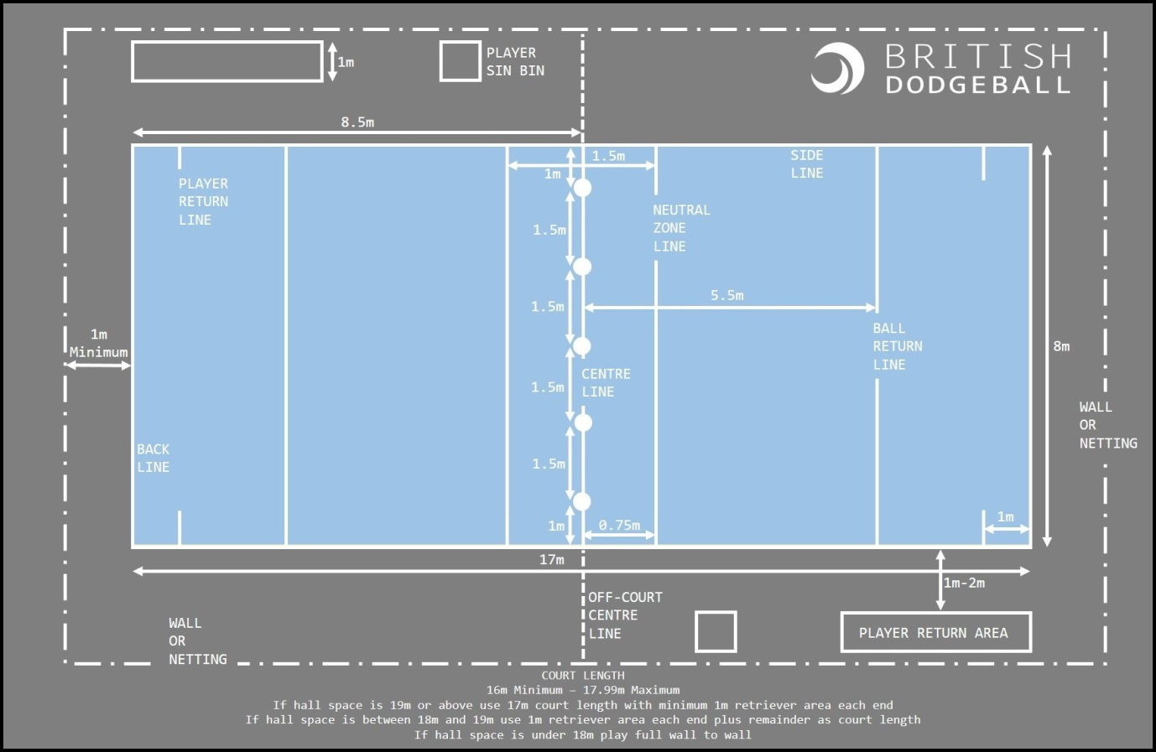

Scoring

- To win a game, eliminate all opposing players or have more players on your side at the end of the game.
- To win a match, you must have more points

Rules

Start of Play

- Start of play- 5 dodgeballs are used and placed along the centre line at the start of each game.
- The 2 balls on a team’s left are their designated balls
- The centre ball is the only contested ball.
- A ball is not live until it is passed back beyond the return line.

Eliminating opposing players

- Live balls- A ball is live until it hits a floor, wall or any other surrounding surface. Multiple play is possible with a live ball.
- Hits- Any player struck with a live ball by an opposing player will be called out. Face shots do not count unless a player’s face stops the ball from hitting their body.
- Catches- Any catch on a live ball will be valid. The player who threw the caught ball will be called out and the catching teams will gain one player from the outbox.
- Blocking- Players are able to use a ball in their possession to block and incoming ball. If the ball they are holding is knocked from their possession, they will be called out.
- Lines- High School dodgeball is played on a dodgeball court. Players are called out for stepping over the side/back lines. Depending on competition type, new players may be warned about line infringements before being called out. Players may leave the court to collect balls by putting their hand up. Players must return to court from behind the back line.
- Stalling- Players should not intentionally stall the game. Once a team has possession of 3, 4 or 5 balls, they should look to make an attempt with at least one of those balls. When a referee calls ‘Play Ball’, a team has 5 seconds to throw. If they do not then players holding balls will be called out. Teams can keep one ball after ‘Play Ball’ has been called, and must throw the rest.
- Multiple Play- The following are examples of multiple play- player will be called out if they are hit by a ball that has deflected off a teammate whilst it is still live. Catch is valid if it has deflected off a teammate whilst it is still live- in this circumstance the hit player plus the thrower will be called out- if the hit player is the first one out, then they will immediately return to the court.

Certificates/Medals/Trophies

Certificates will be given to all pupils who participate in the County Final. Medals will be given to the teams that place 1st and 2nd. There will be a trophy awarded to the team that places 1st.

Progression

- No progression from the County final.

Mini Festival
Summer Festival

Intent

Recruitment

1 girls group and 1 boys group from each SGO area given the opportunity to attend.

Eligibility

- Working with 1 or 2 schools from each SGO area, SGO’s and school staff will identify 10 girls and/or 10 boys from Year 9/10.
- Those pupils identified will be particularly but not exclusively classed as inactive or from underrepresented groups such as low socio-economic backgrounds, ethnically diverse communities and SEND.

Clothing and Equipment Requirements

Some activities will be held outdoors, so pupils will need to bring clothes appropriate to the weather. Warm and waterproof clothing is recommended.

The Process
- Consultation with young people- January/February 2023
The Active Partnership will be able to support delivery of this. Or alternatively, the SGO can undertake the consultation process themselves or alongside the Active Partnership.
- Follow up meeting with young people- April/May 2023
This will be to update the pupils on what will happen at the festival and give them the opportunity to answer any questions. This may not be face to face and could be delivered virtually.
- Schools to attend the Summer Festival- 22nd June 2023
This will be for pupils to take part in the Mini Festival, pupils must also complete feedback on the day before leaving the event.
- Follow up meeting with young people- September/October 2023
This will be to evaluate whether taking part in the festival has changed the pupils outlook on physical activity. E.g. has it improved their physical activity levels, has their mental health improved etc.

Touch Union Rugby
Year 7/8 Girls
Summer Festival

Intent

Recruitment

- The winning team from each Inter-School competition will qualify for the County event.

Eligibility

- Girls must be in Year 7 or 8 only.

Team Requirements

- 8 players on a team with a maximum squad size of 15

Competition Format
- The competition will be played in a round robin format with 2 groups.
- This will be followed by semi-finals and then a final.
- Match time will be 10 minutes straight through with no half time for the round robin stage. For the semi-final and final match time will be 15 minutes straight through with no half time.
- In group tables, a team will receive 3 points for a match won, 2 points for a match drawn and 1 point for a match lost.
- In the event of a tie- if matches are a draw in the ‘group stages’ and there is a tie for who goes through, the following process will be followed:

-Head-to head between the tying teams

-Tries scored

-Tries conceded

Pitch / Playing Area Requirements
Minimum pitch size 40m/20m and maximum 50m/30m.
Rules

General Game Play

- Objective is to score a try by touching the ball down on or over the opponent’s goal line
- 1 Point is awarded for a try
- Defending team aim to stop the attacking team from scoring by making a touch on the ball carrier at the armpit or below
- The attacking team have 6 phases to score
- Ball size 4
- Substitutions -All players must get at least half a game of each game. This is up to the teachers to manage and is done on trust.

Attack

- After first touch tackle by a defender, the ball carrier can run or pass or kick. After the second touch the attacking player must stop / go back the where they were touched, touch the ball on the ground and pass to a team mate
- Ball carrier touch tackled once cannot score and must pass to a support player to score.
- After a second touch (from a different defender/s), ball carrier must: Stop / go back the where they were touched, touch the ball on the ground and pass to a team mate. Pass after second touch tackle must be no more than 2 metres
- Kicking- All kicks must be below head height. If the kick goes into touch = turnover, tap and pass restart to defending team where the ball went out. Ball goes dead in goal from attacker kicking = tap and pass restart to defending team on halfway line.
- No score after 6 phases = turnover. After the 6th touch there is then a turnover. The turnover is a tap and pass from wherever the 6th touch was made.

Defence

  - Defending team make a touch tackle on the ball carrier at the armpit or below
  - A simultaneous touch tackle from two defenders counts as two touches
  - Defending players must retire 2 meters behind the offside line following the second touch
  - Defenders can gain possession by stopping the attack from scoring within their allocated number of phases.
  - Defending team can also gain possession by intercepting the ball or following an infringement from the attack.
  - After conceding a try defending team gain possession with a tap and pass restart on the half-way mark
  - After conceding a penalty, the defending team must retire 10 meters

Certificates/Medals/Trophies

Certificates will be given to all pupils who participate in the County Final. Medals will be given to the teams that place 1st and 2nd. There will be a trophy awarded to the team that places 1st.

Progression

- No progression from the County final.

Sport4All Festival (Soft Archery, Athletics, Boccia and New Age Kurling)
Summer Festival

Intent

Recruitment

- Each district will run an Inter-School event and having taken part in all four sports (Soft Archery, Athletics, Boccia and New Age Kurling- please note some of these sports may differ in each SGO area), two school teams will be selected from each area for the County Final. SGO’s will determine qualification criteria, but the criteria may include:
- Placing at the event
- Following School Games values
- Selection by the SGO
- In total, there will be a maximum of 20 schools taking part in the County event.

Eligibility

- Players must be in year 4 and 5 from each SGO areas’ Primary, Middle and Special schools.
- Players must be selected from a school’s “less active” category and/or SEND.

Team Requirements

- Teams should consist of 4 players
- Teams can be mixed or single gender
- Maximum of 3 teams per school at Inter-School events

Pitch / Playing Area Requirements

- The court dimensions for all 4 sports will be within half a badminton court in a 4-court sports hall.
- Archery will take place in a court adjacent to a wall with targets set against the wall. The distance to target is the width of the badminton court, with archers firing from between the tramlines.
- Adapted area markings should be deployed where the above is not available.

Event Format

Teams will draw to play in each sport against random opponents during an allotted period of time. Event organisers will operate central timing throughout with sports leaders officiating.

Soft Archery Requirements/Rules

Inclusive Soft Archery

- Each team will have a bow and 3 soft tipped arrows, and a team target set up opposite them.
- The team decides the order they will shoot.
- Archers will be told when they can begin shooting.
- The first archer from each team shoots three arrows at their teams target.
- Only once all arrows have been shot by all teams will archers BE TOLD to collect their arrows.
- The scores are collated and posted up on a score board.
- The next archer from each team shoots a further three arrows and the scores added to the team’s total.
- Archers will continue to shoot until allocated time runs out. Current archer will finish firing their 3 arrows, so that all teams end having fired an equal amount of arrows.
- Leaders keep the score and record final score at end of the allocated time.
Athletics Requirements/Rules

- A 15m long obstacle course will be set with a start line and marker cone at the opposite end.
- Athletes run in 2 pairs, one athlete guides and the other wears eyeshades.
- The first pair go on the start signal.
- At the turning point, one of them must touch the cone.
- They return to the start line and the second pair go on a touch handover, the first pair change roles.
- They continue until all 4 have run with eyeshades.
- The time taken for all 4 athletes gives the total team time.

Boccia Equipment Requirements/Rules

- Each team plays 3 games.
- A set of Boccia balls consists of four red, four blue, and one white Jack per game.
- A Boccia ball that is out of play must be placed in a Dead Ball zone so that all competitors can see how many balls are remaining.
- Sports leader officials will indicate which side (red or blue) should play next.
- The aim of the game is to get closer to the jack than your opponent.
- The player to throw the jack ball will follow by throwing their first ball.
- The ball can be propelled by rolling, throwing, kicking or using a ramp.
- All players must be seated during the game on their backside or knees or a wheelchair.
- Teams throw alternately until they run out of balls.
- Once all the balls have been thrown, the side will receive one point for every ball they have closer to the jack than the other team.
- A ball will be considered out of court if it crosses the boundary line.
- Leaders keep the score and record final score at end of the allocated time.
New Age Kurling Equipment Requirements/ Rules

- Each team plays 3 games.
- A set of Kurling stones consists of four red, four blue, and one target per game.
- The aim of the game is to roll the Kurling stones in to the centre of the designated target.
- All players must be seated on backside, knees or in a wheelchair at all times.
- Leaders keep the score to an agreed format and record final score at end of the allocated time.
Certificates/Medals/Trophies
Certificates will be given to all pupils who participate in the County Final. Tokens based on the School Games values of Self-belief and Teamwork will be given out by leaders. The total number of tokens will be combined with points awarded for each activity. These totals will then be combined and medals will be given to the teams that place 1st and 2nd. There will be a trophy awarded to the team that places 1st.

Progression

No progression from the County event.

